# Information Retrieval & Text Mining

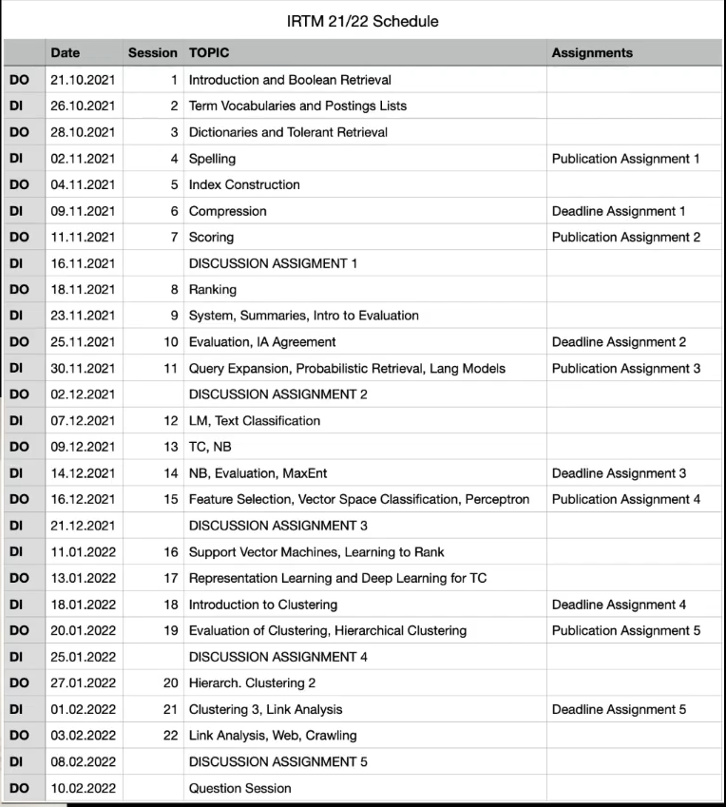

* Information Retrieval
* Text Mining:
  + Extract information from unstructured text
* Book:
  + http://informationretrieval.org

# Formalities

* Lectures on Tuesdays and Thursdays
* 55.01 🡪 videos uploaded in the evening
* 5 home work assignments!
* Register in Campus:
  + Assignments (Hausübungen)
    - 80 points in assignments to write exam.
    - 100 points in pen&paper exercises.
    - 50 points in practical exercises 🡪 points granted for submission of correct and well documented code/result.
    - Do it alone.
  + Written exam (not used because Vertiefungslinie)
  + Vertiefungslinie

# Lecture 1 - Boolean Retrieval

What is information retrieval?

* IR is finding material (documents) of an unstructured nature (text) that satisfies an information need from within large collections, usually stored on computers.
* Satisfies an information need.

What is Text Mining?

* Text mining is the derivation of information (structured form) from unstructured text. In contrast, data mining is typically applied on structured data. Typically, methods from information retrieval are used.
* Conversion process from text to data.

Why there is more unstructured data in contrast to structured databases?

* No need to structure data 🡪 blog posts
* Text is a natural form on communication
* Text is more accessible
* Structuring data is expensive

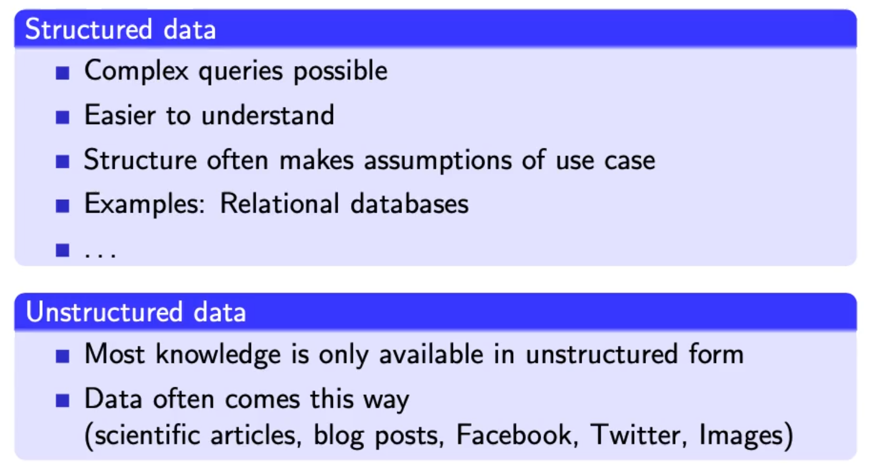

Boolean retrieval:

* Boolean model: simplest model to base an information retrieval systemon
* Queries and boolean expression e.g. Caesar and Brutus
* Search engine returns all documents that satisfy the Boolean expression
* Does Google use the Boolean model?
  + Query expansion with synonyms
  + Cases where you get hits that do not contain one of the words:
    - Anchor texts
    - Page contains variant of word (synonym, spelling correction)
    - Long queries (n large)
    - Boolean expression generates very few hits
* Simple boolean retrieval returns matching documents **in no particular order.**
* Most Boolean engines rank the result set – they rank good hits (**according to some estimator of relevance**) higher than worse hits.

## Inverted Index

* Which plays of Shakespare contain the words Brutus & Caesar but NOT Calpurnia?
  + grep “Brutus” | grep “Caesar” | grep -v “Calpurnia”
    - inefficient, scan all documents 3 times
    - grep doesn’t know what a “word” is, Caesar-Salad would also be a hit.
    - Grep is line oriented, IR is document-oriented
    - Other operations 🡪 find close words “romans” / “countrymen”

## Term-document incidence matrix

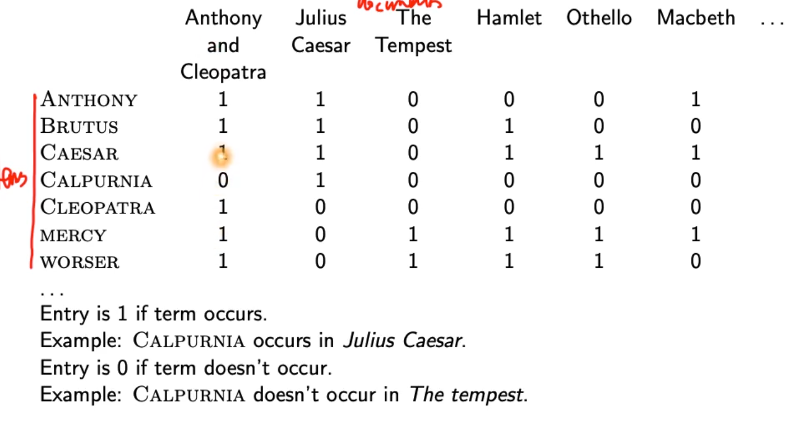

* Can’t build incidence matrix for big collections (1 million docs, 1000 words per doc 🡪 half trillion 0/1)
* Extremely sparse matrix 🡪 only record the ones

## Inverted index

* Point from terms to documents:
* 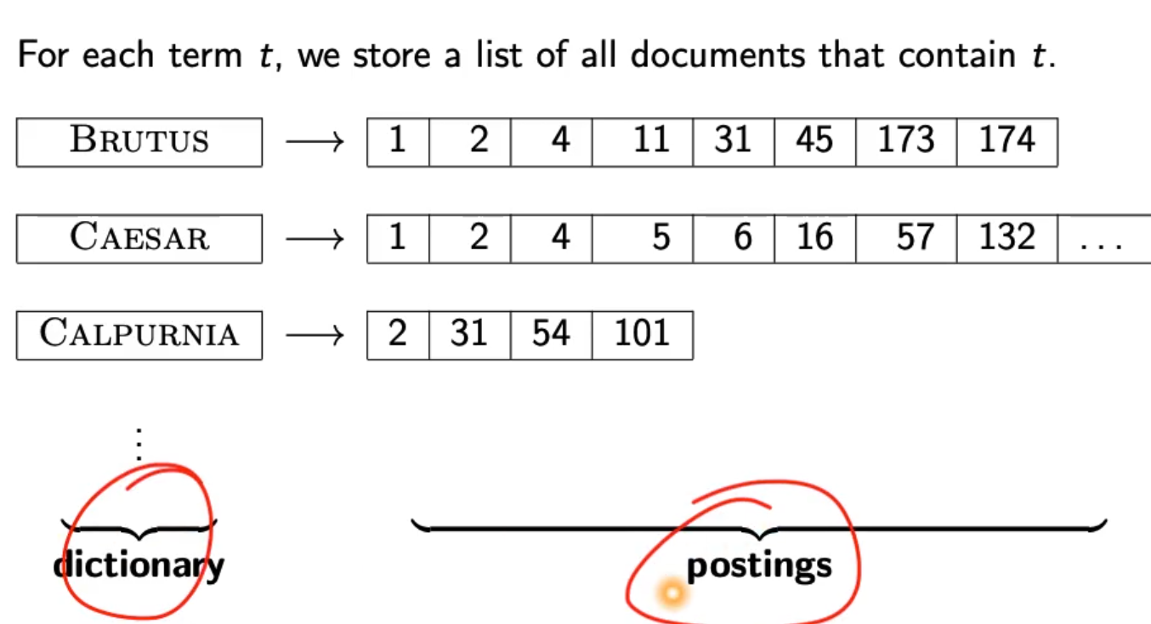
* 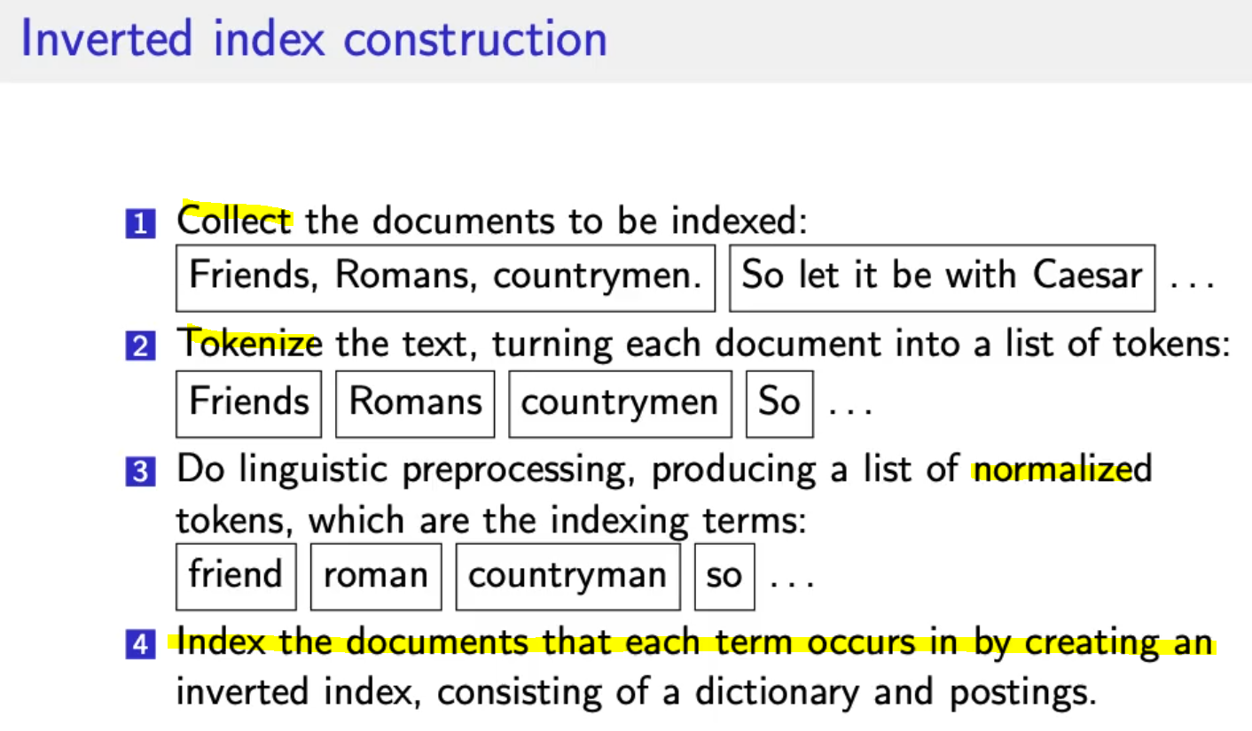
* 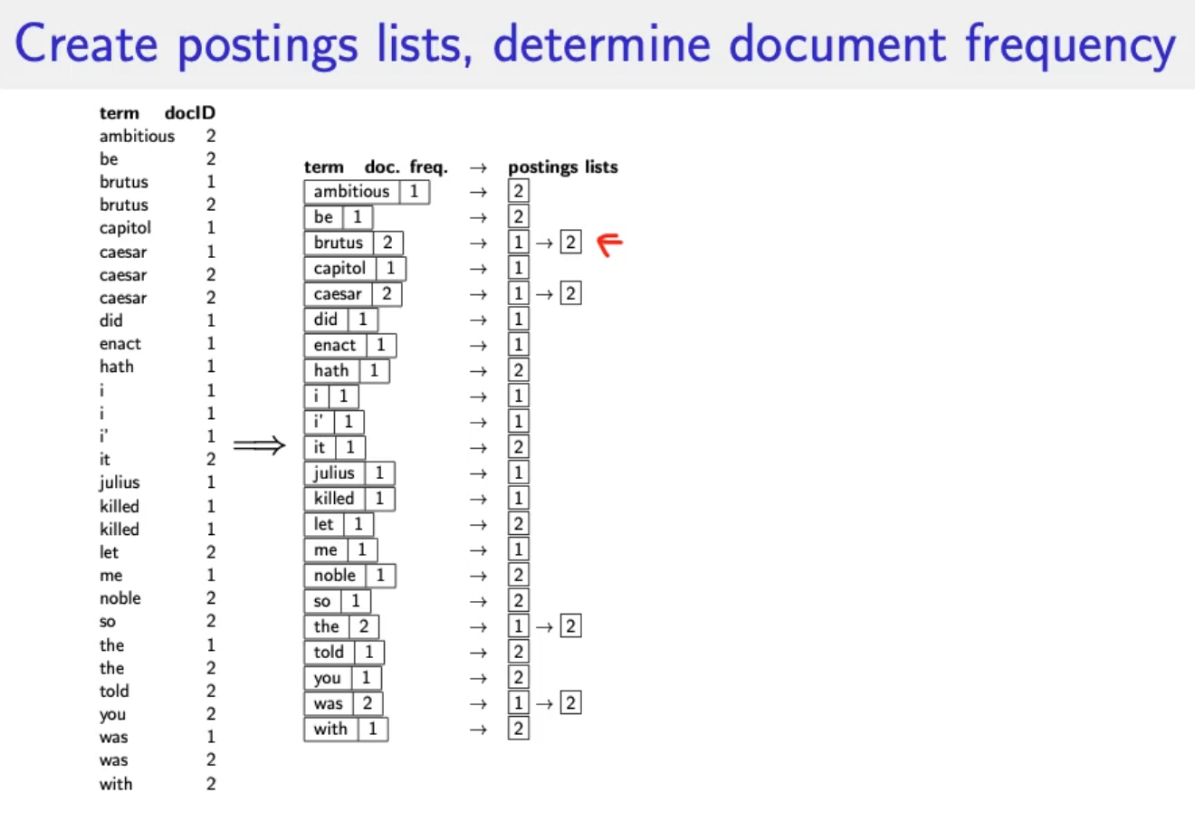
* 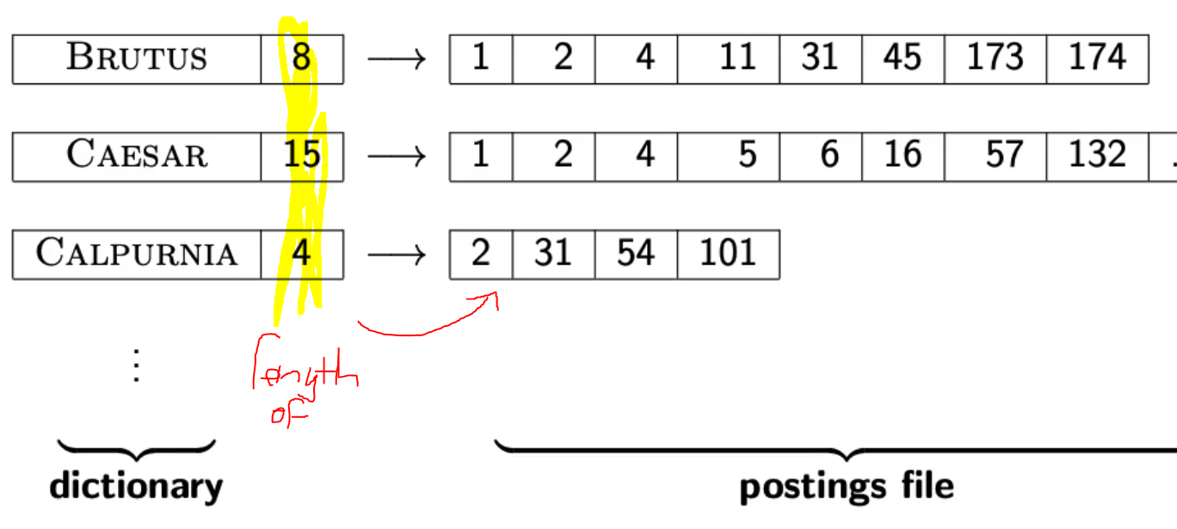
* 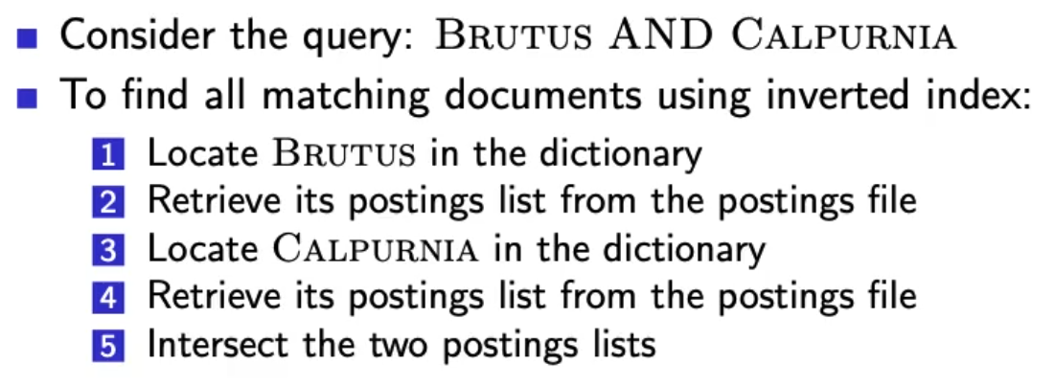
* Runtime of intersecting the two lists?
  + Linear in the sum length of the postings lists
  + This only works if posting lists are sorted

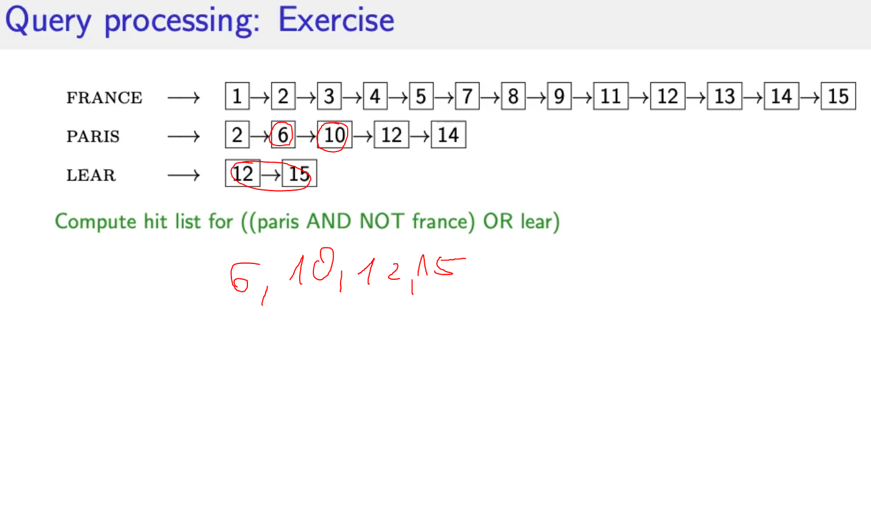

* Boolean retrieval model can answer any query that is a boolean expression
  + AND, OR, NOT
  + Views each document as a set of terms
  + Precise: Document machtes or not, nothing in between
  + 🡪 Primal retrieval tool for at least 3 decades
  + Many professional searches (lawyers, patent offices, …) prefer boolean queries
    - You know exactly what you are getting
    - No Google “magic”
  + Westlaw: big law search engine
    - /3 within 3 words
    - /s within a sentence
    - /p within a paragraph
    - Long precise queries, incrementally developed not like a web search
  + 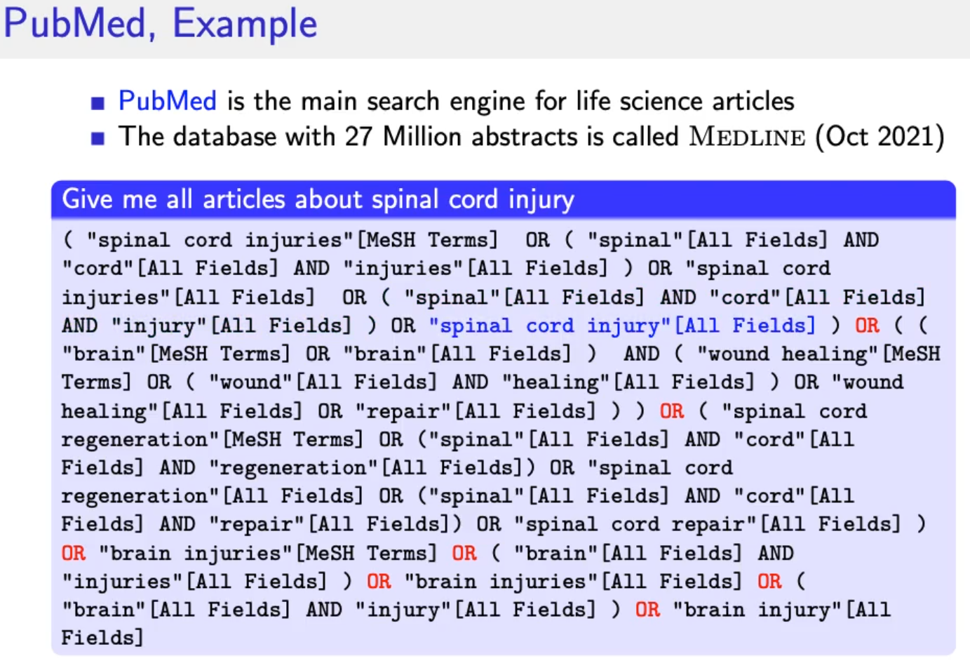 🡪 needs query optimization

## Query Optimization

* Consider a query that is and of n terms, n>2
* For each of the terms get postins list, then AND them together
* Example query:
  + BRUTUS and CALPURNIA and CAESAR
  + 🡪 check the shortest posting list and start with these 🡪 fewer comparisons in the next step
* Example query:
  + (MADDING or CROWD) and (IGNOBLE or STRIFE)
  + Get frequencies of all terms
  + Estimate the size of each or by the sum of its frequencies (conservative)
  + Start with shortest

# Lecture 2 – Voc

## Documents

* Spoken language
* Handwritten texts
* Scanned documents
* Paper documents
* Signed language (Gebärdensprache)
* Format / Language
  + Format pdf, excel, html
  + Language
  + Character set
  + General approach:
    - Converter for each format to a generic format
  + A single index/document contains terms of several languages
    - French email with spanish pdf attachment
  + Document unit?
    - 1 file
    - 1 email
    - Mail + all attachments
    - Group of files (LaTex)
    - What about XML?
* Issues
  + Mathematical equations in documents
  + OCR/Scan 🡪 Which column belong together?
  + Hyphenization 🡪 detect and put words together
  + HTML pages (Advertisements, Images)
  + Issues with proprietary formats

## Terms

* Token: Character sequence in a document
  + Closely related to one Word
  + Punctuation is also a token != word
* Type: equivalence class of tokens
  + Related to Term: (normalized) type 🡪 thing we put in dictionary
* Term: as it occurs in IR system’s dictionary
* Example:
  + “I like the coffee, cofees, and the shop.
  + How many tokens? Types? Terms?
  + 11 tokens
  + 9 types (commas and the, the)
  + 8 terms 🡪 plural coffee and coffees

## Normalization

* + Normalize words in indexed text as well as query terms into the same form
  + U.S.A. = USA, coffees = coffee
  + Two approaches:
    - **Implicitly define equivalence classes of terms (rules)**
    - **Asymmetric expansion**
      * Window -> window, windows
      * More powerful but less efficient
  + Normalization process and language detection interact
    - PETER WILL NICHT MIT! 🡪 MIT = mit
    - He got his PhD from MIT. 🡪 MIT != mit

Übung:

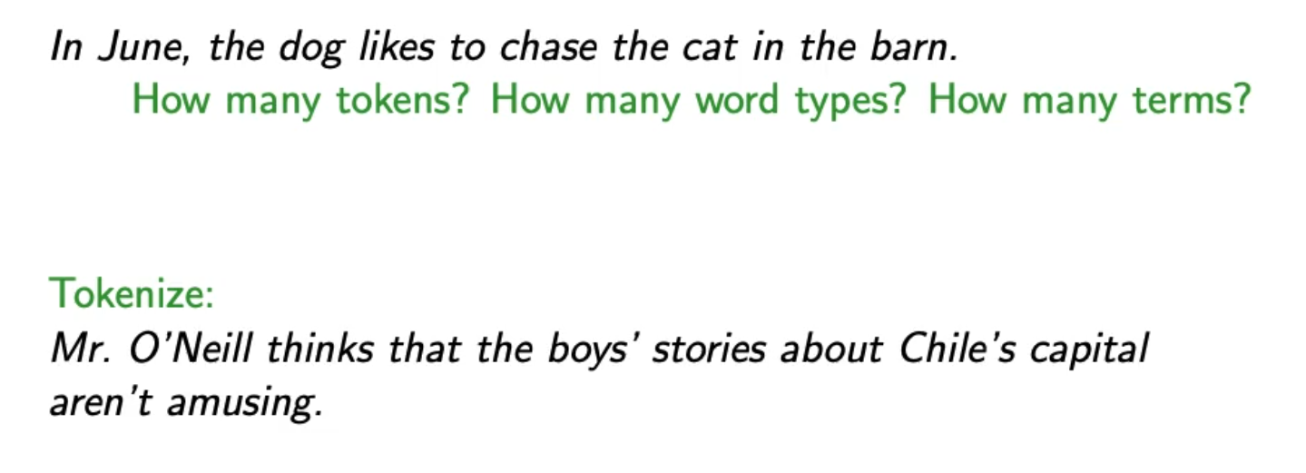

* First example:
  + 14 tokens
  + 12 types (In != in), (the=the=the)
  + 11 terms
* Second example:
  + Mr. | O’Neill | thinks | that | the | boys’ | stories | about | Chile’s | capital | aren’t | amusing | . |
* Tokenization problems:
  + Hewlett-Packard = one word
  + State-of-the-art = adjective
  + co-education
  + the hold-him-back-and-drag-him-away maneuver = ineffiecnet to get all words
  + data base
  + San Francisco = one token
  + Los Angeles-based company 🡪 we need a dictionary of names
  + Cheap San Francisco-Los Angeles fares
  + York University vs. New York University (what if search for york university and we find new york?)
  + Numbers
    - 3/20/91 🡪 know what it is
    - 20/3/91
    - Mar 20, 1991
    - Normalize dates to the same format
    - B-52 🡪 Bomber
    - 100.2.86.144 🡪 ip address?
  + Chinese:
    - No whitespace
    - Compounds in German 🡪 Donaudampfschifffahrtsgesellschaft
  + Arabic script: bidirectionality
    - 
  + Accents:
    - Résumé vs resume
  + Umlaute
    - Universität vs Universitaet
  + How are users likely to write their queries for these words?
  + Even in languages that standardly have accents, users often do not type them e.g. Polish.

### Normalization of English

* Case folding 🡪 all letters to lowercase
* Even though case ca be meaningful
  + MIT vs. mit
  + Fed vs fed vs FeD vs FED
* Best to lowercase everything
* Counter example:
  + Human gene CES4A
  + Rat gene name Ces4a (by convention only first character)

### Stopwords

* Extremely common words which would appear to be of little value in helping selecting documents matching user need
* A, an, and, the, was, to ,that, on, from, for
* Stop word elimination used to be standard in IR systems
* Stop words for phrase queries 🡪 King of Denmark
* Most web search engines index stop words

### Soundex

* Equivalence classes based on phonetics
* Muller = Mueller

### Thesauri / Ontologies

* Semantic equivalence 🡪 car = automobile

### Lemmatization

* Reduce inflectional/variant forms to base form
* Am, are, is 🡪 be
* Car, car, car’s 🡪 car
* The boy’s cars are different colors 🡪 the boy car be different color
* Lemmatization implies doing proper reduction to dictionary headword
* Inflectional morphology:
  + Cutting 🡪 cut
* Derivational morphology:
  + Destruction 🡪 destroy

### Stemming

* Heuristic process that chops off the ends of words
* Achieve “principled” lemmatization
* Language dependent
* Inflectional AND derivational
* Example for derivational (other meaning)
  + Automate, automatic, automation 🡪 automat
* Porter algorithm most common algorithm for stemming in English
  + Conventions and 5 phases of reductions
  + Phases are applied sequentially
  + Each phase consists of a set of commands
  + Sample command:
    - 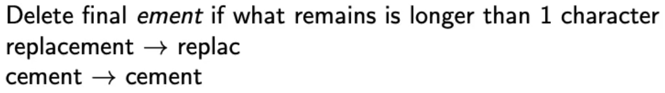
  + Always apply the longest rule 🡪 applies to the longest suffix
  + Subset of rules:
    - 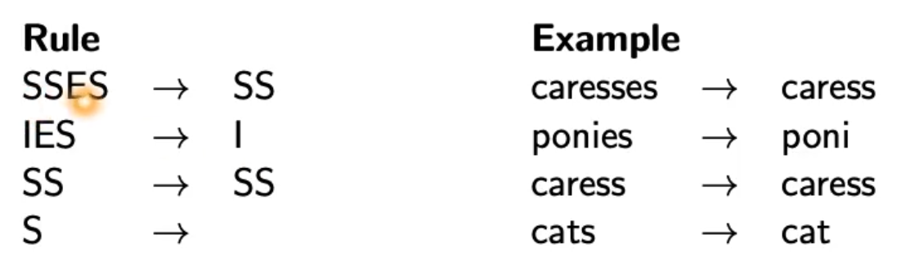
* Different stemmers lead to different results
* Sometimes stemming increases effectiveness, sometimes decreases!

## Skip pointers

* Skip pointers enable intersection algorithm to skip postings that will not figure in the search results
* Intersecting becomes more efficient
* 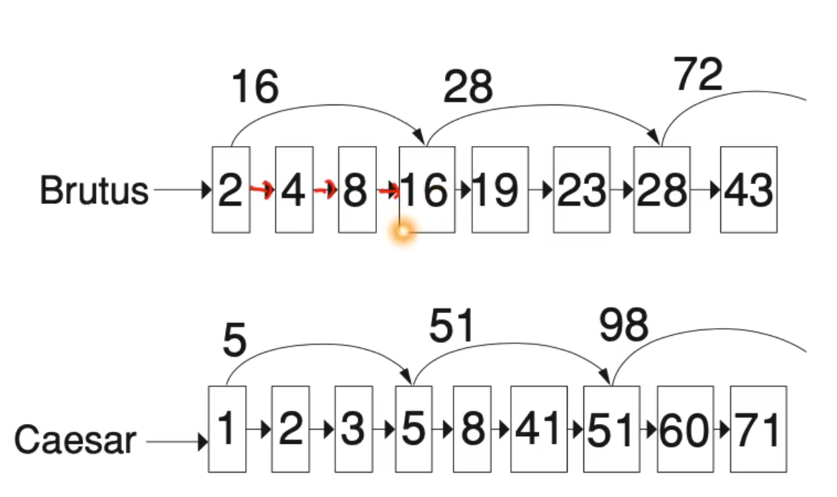
* Tradeoff
  + Number of skiped items
  + Frequency how often can we skip?
    - More skips: skip pointer only skips few items but we can frequently use it.
    - Fewer skips: skip pointer skips many items but we can’t use it very often.
* Simple heuristic:
  + For postings list of length P use sqrt(P) evenly-space skip pointers
  + This ignores the distribution of query terms.
* Easy if index is static, harder when index is dynamic!

# Lecture 3 – Phrase Queries, Dictionaries

## Soundex

* Soundex is basis for finding phonetic (as opposed to orhographic) alternatives
* Example: chebyshev / tchebyscheeff
* Algorithm:
  + Turn every token to be indexed into a 4-character reduced form
  + Do the same with query terms
  + Build and search an index based on these reduced forms
  + 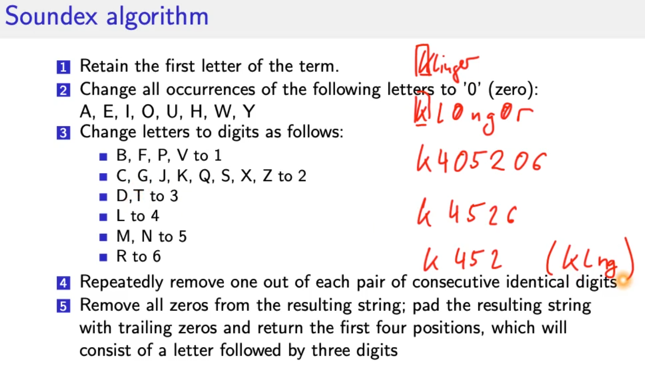
* For general information retrieval not very useful
* Ok for high recall tasks (Interpol)
* HASENBALG
* H0S0NB0LG
* H02051042
* H251 🡪 HSNB

## Phrase queries

* Stanford university as phrase
* “The inventor Stanford Ovshinksky never went to university” 🡪 should not be a match
* Easily understood concept for end users (only 10% are explicit phase queries)
* Consequence for inverted index 🡪 it no longer suffices to store docIds in postings lists
* Three remedies:

### Biword index (phrase index)

* + - * Index every consecutive pair of terms in the text as phrase
      * Each biword is now vocabulary term
      * Two-word phrases can easily be answered
      * 🡪 increase tri-word, quad-word index etc. but inefficient
      * Why are biword indexes rarely used?
        + Index blowup
        + False positives

### Positional index

* + - * More efficient
      * Postings list in a positional index:
        + Each posting is a doc Id and a list of positions (where does the term occur in the document?)
      * Query: compare list of positions of postings, if order matches it’s a hit
      * Also use it for proximity search (comparison value = 4)
        + Employment /4 place
      * Google:
        + Test * Data 🡪 low distance
        + Test **** Data 🡪 high distance
      * Show actual matching positions to user!

### Combination of biword/positional

* + - * Many biwords are extremely frequent:
        + Micheal Jackson, Britney Spears
      * For these biwords increased speed compared to positional postings intersection is substantial!
      * Frequent biword included in index, everythin else positional index!

**Positional queries are much more expensive than regular Boolean queries.**

## Dictionaries

* How to store data structure
* Dictionary: data structure to store term vocabulary
* Term vocabulary: the data
* For each term we need to store a couple of items:
  + Term
  + Document frequency
  + Pointer to postings list
  + Assume we can store this info in a fixed-length entry!
  + We store these entries as array.
  + 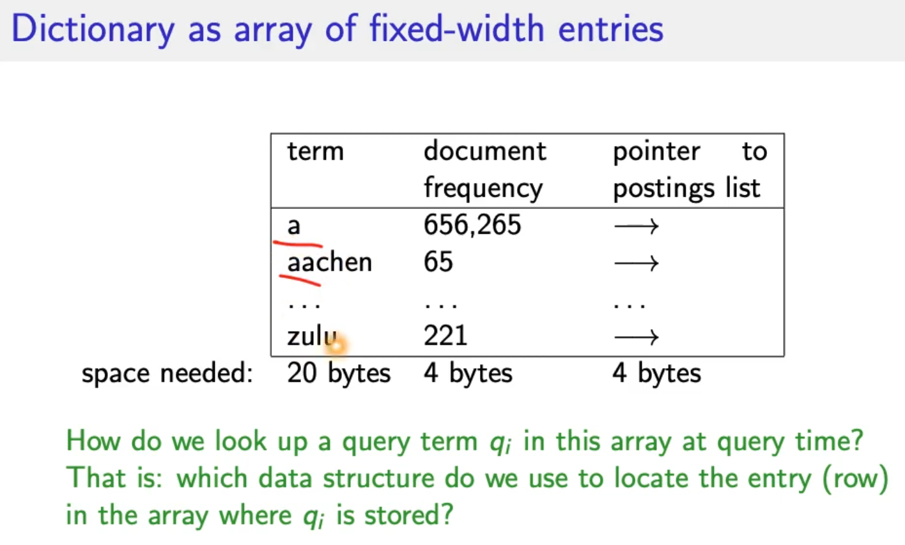
* Data structures for looking up term
  + Criteria:
    - Is there a fixed number of terms or will it keep growing?
    - What are the relative frequencies with which various keys will be accessed?
    - How many terms are we likely to have?
  + Hashes
    - Each vocabulary term is hashed into an integer
    - This number is the row number of the array
    - At query time: hash(query term) = row 🡪 super quick, runtime O(n), faster than tree
    - Disadvantage:
      * no way to find minor variants (resume vs résumé) 🡪 Hash function doesn’t know about language!
      * Lookup time depends on hash function
      * No prefix search (all terms starting with automat)
  + Trees
    - Solves prefix problem 🡪 find all terms starting with automat
    - Simplest tree: binary tree
    - Slower than hashes O(log M) (holds for balanced trees) 🡪 M = size of vocabulary
    - Rebalancing binary trees is expensive
    - B-trees address the rebalancing problem
    - 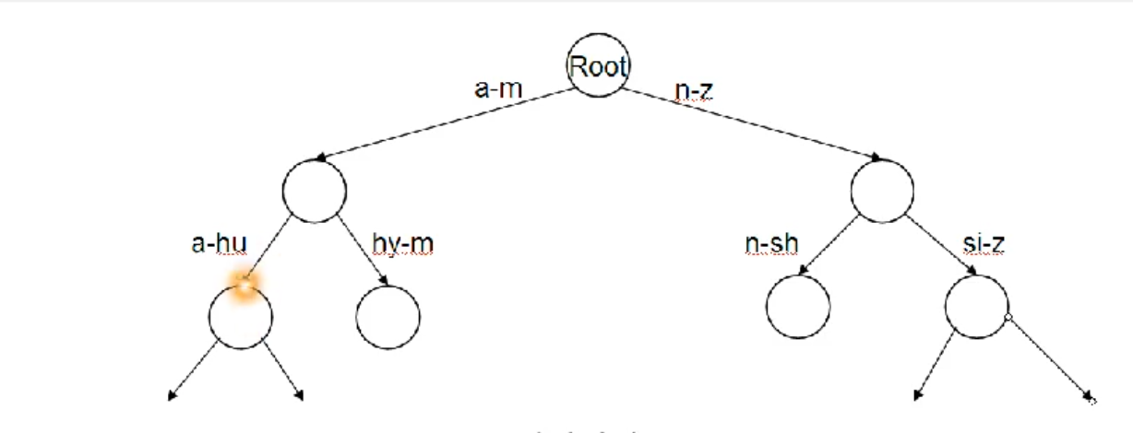

# Lecture 4 – Tolerant Retrieval & Spelling Correction

## Wildcard queries

* Mon* 🡪 find all docs containing any term beginning with mon
  + Easy with tree dictionary 🡪 retrieve all terms t in range mon <= t < moo
* *mon 🡪 find all docs containing any term ending with mon
  + Duplicate tree, reverse terms (factor 2 memory consumption)
  + Find terms in range nom <= t < non
* Result: Set of terms that are matches for wildcard query
* M*nchen
  + Lookup m* and *nchen in both trees and intersect (Expensive)
  + Alternative: **permuterm index**

### Permuterm Index ???

* Rotate every wildcard query, so that the * occurs at each possible position
* Store each of these rotations in an additonal dictionary which maps to the original term
* 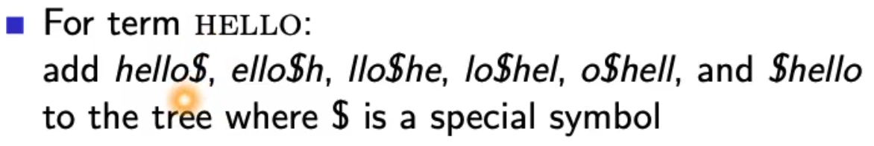
* Permuterm 🡪 term mapping
* 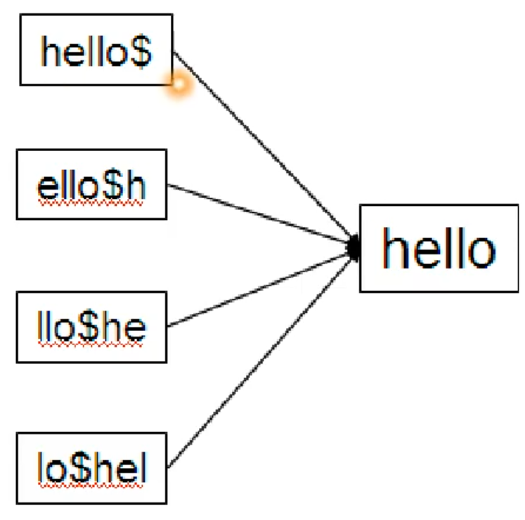
* Queries
  + For X, look up X$ e.g. hello
  + For X*, lookup $X* e.g. hel*
  + For *X, lookup X$* e.g. *lo
  + For *X*, lookup X* e.g. *ell*
  + For X*Y, lookup Y$X* e.g. hel*o 🡪 o$hel*
* Multiple wildcards in one query cannot easily be handled with this data structure (except case above)
* Rotate query wildcard to the right
* Use tre lookup as before
* Permuterm empirically more than **quadruples** the size of dictioanry compared to regular tree.

### k-gram Indexes

* More space efficient than permuterm index
* Enumerate all character k-grams (sequence of k characters) occuring in a term
* 2-grams = bigrams, 3-grams = trigrams
* April is the cruelest month 🡪 bigrams:
  + $a ap pr ri il l$
  + $i is s$
  + $t th he e$
  + $c cr ru ue el le es st t$
  + $m mo on nt h$
* $ special word boundary symbol
* Maintain inverted index from bigrams to terms that contain that bigram
* 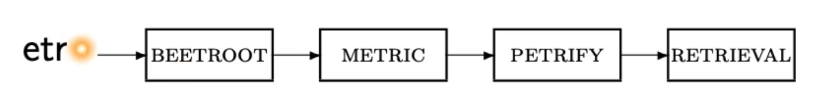
* With this approach: 2 different types of indexes
  + Term-document inverted index for finding documents based on a query consisting of terms
  + K-gram index for finding terms based on a query consisting of k-grams
* Query mon* can now be run as:
  + $m AND mo AND on
  + Returns all terms with the prefix mon
  + And many false positives 🡪 MOON 🡪 AND-operator has no order
  + postfilter these terms against query
  + Lookup result of filter in term-document inverted index

**K-gram index is more space efficient, but post filtering**

**Permutation index more space but no postfiltering.**

**Why doesn’t Google fully support wildcard queries? 🡪 Expensive**

### Processing wildcard queries in the term-doccument index

* Problem 1
  + Potentially large number of Boolean queries
  + Most straightforward semantics: Conjunction of disjunctions
  + Very expensive
* Problem 2
  + Users hate to type
  + If abbreviated queries are allowed, users will use them a lot!

## Edit distance

Two use cases:

* Correcting documents being indexed
* Correcting user queries

Two different methods:

* Isolated word spelling correction
  + Check each word on its own for misspelling
  + Will not catch typos resulting in correctly spelled words:
    - An asteroid that fell form the sky
* Context-sensitive spelling correction
  + Look at surrounding words
  + Can correct form/from error from above

### Correcting documents

* In IR for errors in documents, e.g. OCR character recognition.
* General philosophy in IR: don’t change the documents.

### Correcting queries

* Premise 1: There is a list of “correct words” from which the correct spellings come from.
  + Dictionary
  + Industry-specific dictionary
  + Term vocabulary of the collection, appropriately weighted (remove very infrequent words)
* Premise 2: We have a way of computing the distance between a misspelled word and a correct word.
* Simple spelling correction algorithm: return correct word with smallest distance to misspelled word.

### Edit distance

* The edit distance between s1 and s2 is the minimum number if basic operations that convert s1 to s2.
* Levenshtein distance:
  + Basic operations: insert, delete and replace
  + dog do 🡪 1 (insert)
  + cat cart 🡪 1 (insert)
  + cat cut 🡪 1 (replace)
  + cat act 🡪 2 (insert, delete)
* Damerau-Levensthein distance (+ operation transposition = exchange) :
  + cat act 🡪 1 (transposition operation)
* How to compute distance 🡪 Dynamic Programming problem
* 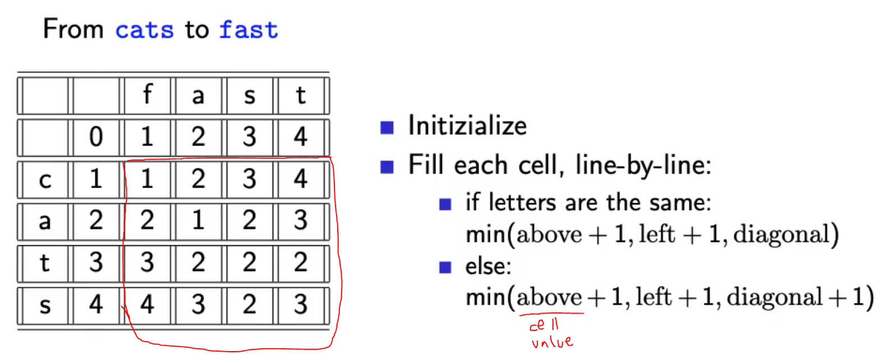
* Bottom right corner is minimum Levenshtein distance = 3
* 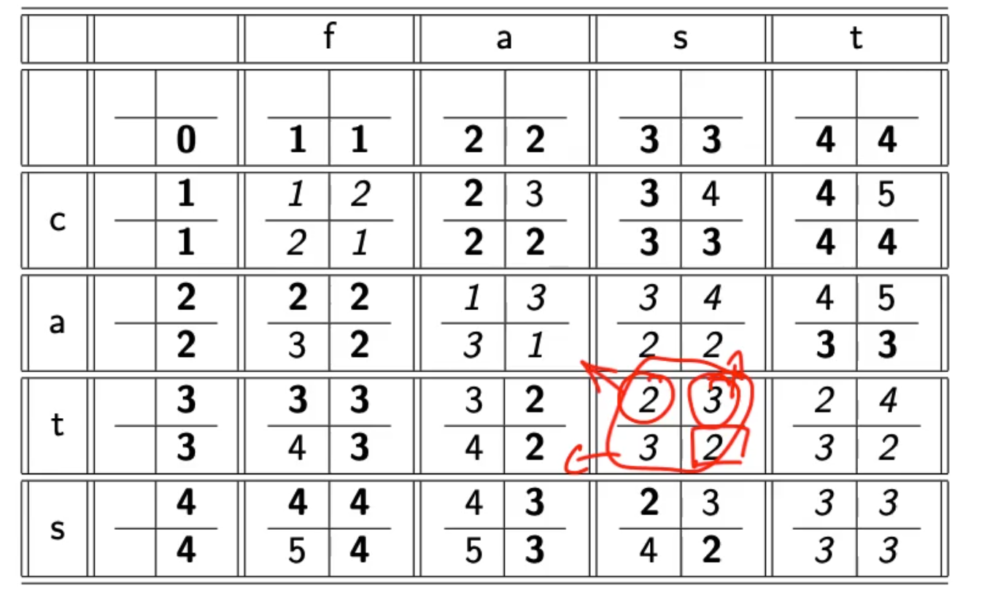
* If we need to backtrack we can write it like this 😊
* 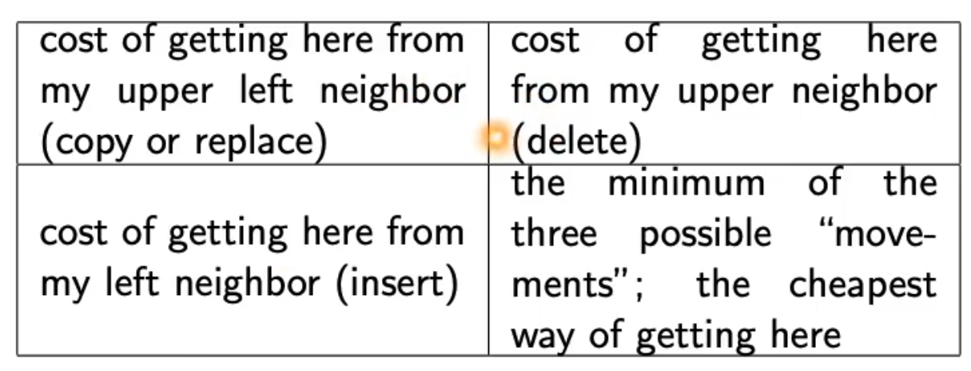

### Weighted edit distance

* Weight of an operation depends on the characters involved
* 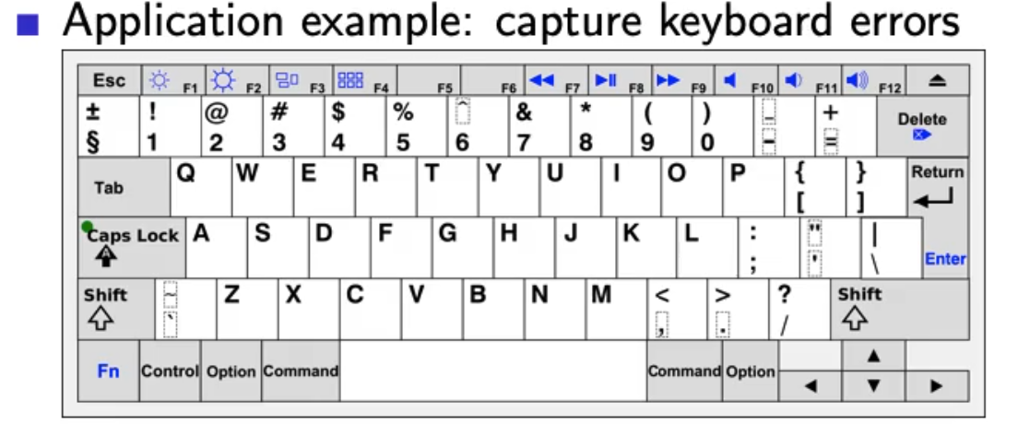
* M more likely to be mistypes as n than q
* Replacing m by n is smaller edit distance than replacing m by q!
* We require a weight matrix as input 🡪 Modify algorithm to handle weights

### Using edit distance for spelling correction

* Comparing query to all dictionary terms is very expensive!
* Approach 1:
  + Compare to all terms, but stop after specific edit distance (avoid unnecessary computations)
* Approach 2:
  + Generate all writing variations of query and compare to dictionary
* Approach 3:
  + Add some writing variations of the dictionary to the dicitionary 🡪 expensive but precalculated, increases dictionary size

### Example Levenshtein OSLO-SNOW

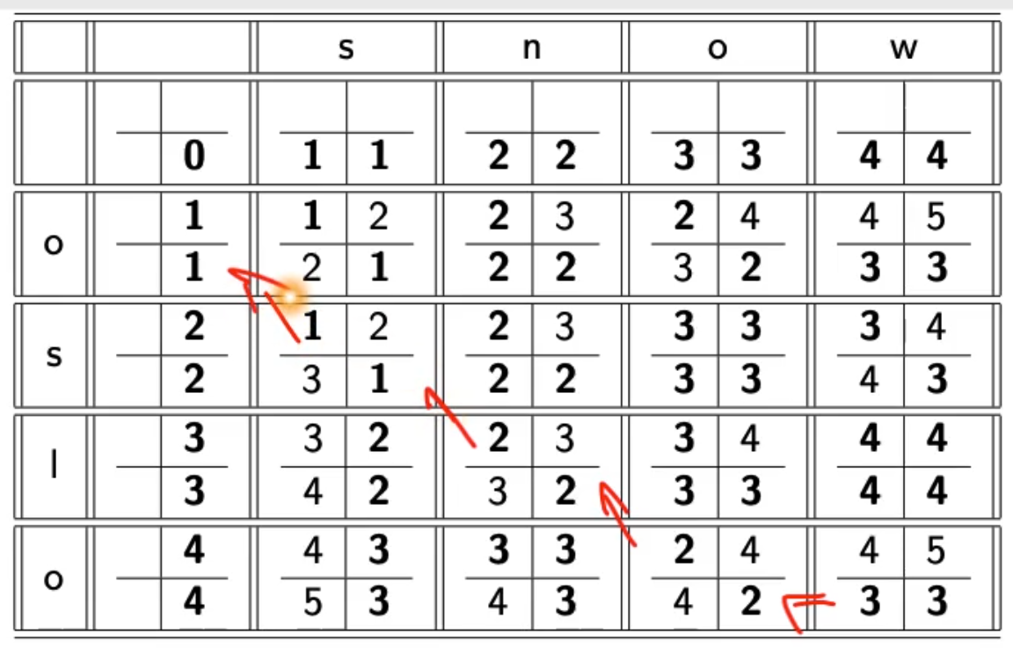

## Spelling correction

### k-gram indexes for spelling correction

* Enumerate all k-grams in the query term
* Example: bigram index_ misspelled word bordroom
* Bigrams: bo, or, rd, dr, ro, oo, om
* Use the k-gram index to retrieve correct words that match query term k-grams
* Threshold by number of matching k-grams
* E.g., only vocabulary terms that differ by at most 3 k-grams
* 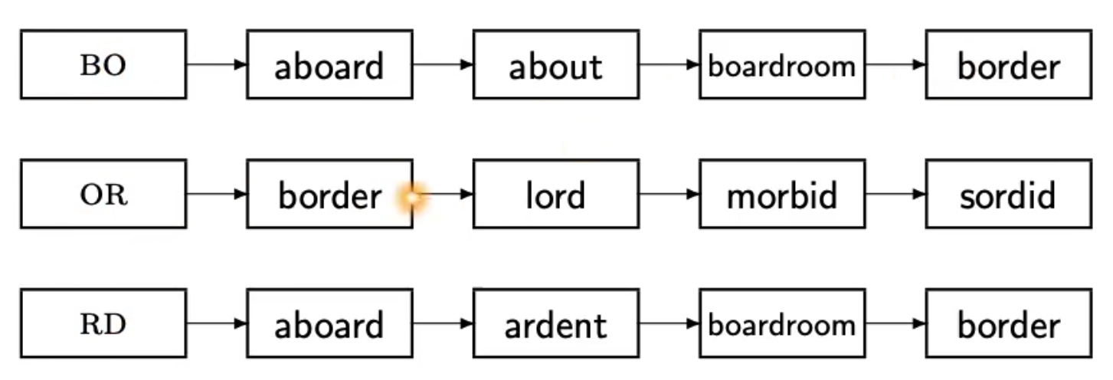
* Apply intersection algorithm which contain all bigrams 🡪 boardroom
* Fixed number of k-grams that differ does not work for words of differing length!
  + NOVEMBER
  + Trigrams: nov, ove, vem, emb, mbe, ber
  + Query term DECEMBER:
    - Matches: emb, mbe, ber
  + 3 trigrams overlap out of 6 for each word, 9 different overall.
* How can we turn this into a normalized measure of overlap?

### Jaccard coefficient

* Measure overlap of two sets
* Let A and B be two sets
* Jaccard coefficient:
  + How many trigrams occur in both terms
  + Overall number of trigrams
  + 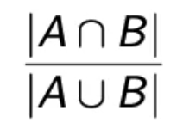
* If A=B 🡪 1 perfect
* If no overlap 🡪 0 no match
* Always assings value between 0 and 1.
* DECEMBER NOVEMBER 🡪 3/9 🡪 1/3
* Application to spelling correction: declare match if the coefficient is > 0.8

### Context-sensitive spelling correction

* „an asteroid that fell form the sky“
* Hit-based spelling correction
  + Retrieve correct terms close to each query term
  + For „flew form munich“
    - Flea for flew
    - From for form
    - Munch for munich
  + Now try all possible resulting phrases as queries with one word „fixed“ at a time
    - Flea form munich
    - Flew from munich
    - Flew form munch
  + The correct query „flew from munich“ has the most hits
  + Not very efficient, combinatorial explosion

#### General issues in spelling correction

* User interface
  + Show user results of spelling correction and let user decide (can be overwhelming)
  + Automatic vs. Suggested correction
  + *„Did you mean“* only works for one suggestion
  + **Simple** vs. Powerful UI (Google)
* Cost
  + Spelling correction is potentially expensive
  + Avoid running on every query 🡪 maybe just on queries that have few matches
  + Guess: modern search engines use spelling corrections

# Lecture 5 – Index Construction

* Distributed index construiton: MapReduce
* Dynamic index construction: how to keep the index up-to-date as the collection changes
* Open source indexing library lucene

## Introduction

* Design decisions are based on hardware constraints

## Reuters RCV1 statistics

* 800k docuents
* 200 tokens per document
* 400k terms
* 6 bytes per token
* 7.5 bytes per term
* 100 Million non-positional postings
* Average frequency of a term
  + 400k / 800k*200 = 0.0025
* How many positional postings?
  + 100 M * 200 = 20 Gigabyte

## BSBI

* Sort based index construction
* As we build index, we parse docs one at a time
* The final postings for any term are incomplete until the end.
* Can we keep all postings in memory and then do the sort in-memory at the end?
* Disk access is not allowed.

## External sorting algorithm

* Sort 100M non-positional postings
  + Each posting has 12 bytes
* Define block of 10M such postings
  + We can easily fit that many postings into memory
  + Blocks of term id/document id pairs
  + For each block
    - Accumulate postings
    - Todo
    - Todo
* Problem: keep entire dictionary in memory in order to implement term 🡪 termID mapping.

## Single-pass in-memory indexing (SPIMI)

* Generate separate dictionaries for each block – no need for termID mapping
* Don’t sort across blocks/ term-DocId paris, accumulate postings in postings lists as they occur
* 1 index per block, then combine
* ??? why don’t sort?

## Distributed indexing

* Uses a distributed computer cluster
* Individual machines are fault-prone
* How to exploit such a cluster?
* Maintain master machine directing the indexing job – considered „safe“
* Break up indexing into sets of parllel tasks
* Master machine assigns each task to idle machine
* Two sets of tasks
  + Build subsolutions (Parsers)
    - Parser reads a document at a time and emits (term, docId) pairs
    - Parser writes pairs into j term-partitions
    - TODO
  + Merge subsolutions (Inverters)
    - Sees terms partitions
    - Collects (term,docID) pairs 🡪 takes all (a-f) partitions from all Parsers
    - Sorts and wirtes to postings lists
    - Data flow (ugly image) TODO
* Break the document collection into splits (block) = subset of documents

## Dynamic Indexing

* Dynamic collections that change over time
* Docs
  + Insert
  + Delete
  + Modify
* Dynamically modify
  + Dictionary (add /remove terms)
  + Add/remove elements from a postings list
* Naive approach:
  + Rebuild index from scratch from time to time (if small than its actually easy)
* Simple approach:
  + Maintain big main index on disk
  + New docs go into small auxiliary index in memory
  + Search accross both and merge results
  + Periodically merge auxiliary index into big index
  + Deletions:
    - Invalidation bit-vector for deleted docs (flagged)
    - If flag is set, remove from results shown to user
  + Issues:
    - Frequent merges
    - Poor search performance during index merge (disk seeks)
* Logarithmic merge
  + Series of indexes, increase by factor 2
  + Keep smallest Z0 in memory
  + Larger ones on disk
  + If Z0 gets too big (>n), write to disk as IO
  + TODO…… copy table from lecture video

|  |  |  |  |  |
| --- | --- | --- | --- | --- |
| Z0 | I0 | I1 |  |  |
| 50 |  |  |  |  |
| 50 | 50 |  |  |  |
| 50 |  | 100 |  |  |
| 1 | 50 | 100 |  |  |
|  |  |  |  |  |
|  |  |  |  |  |

## Lucene

* Open source Java library
* Lets you add search to your application
* Not a complete search system by itself
* Used by: wittre, LinkedIn, Reddit, CiteSeer
* Ports integration to other languages

# Lecture 6 - Compression

* Motivation
  + Less disk space
  + Keep more stuff in RAM
  + Increase speed of transferring data from disk to RAM
    - Read compressed data and decompress in memory is faster than reading uncompressed data (if decompression algos are fast)
* Lossy vs. Losless compression
  + Lossy: discard compression (e.g. MP3, JPEG)
    - Preprocessing 🡪 lossy compression (downcasing, stop words, stemming, number elim)
* How can we compress the dictionary of the inverted index?
* How can we compress the postings of the inverted index?
* Term statistics: how are terms distributed in document collections and how can we estimate this number?

## Term statistics

Lossy compression by preprocessing:

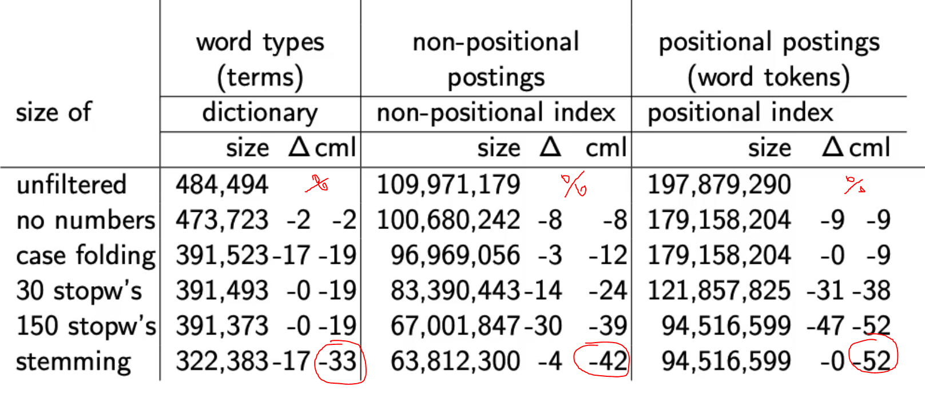

## Heap’s law: Can we assume there is an upper bound?

* Not really: many long words, very infrequent
* The vocabulary will keep growing with collection size, but how much?
* Heap’s law: M= kTb
  + M is the size of the vocabulary
  + T is number of tokens in collection
  + Typical values for k and b are:
    - 30 <= k <= 100
    - b ~ 0.5

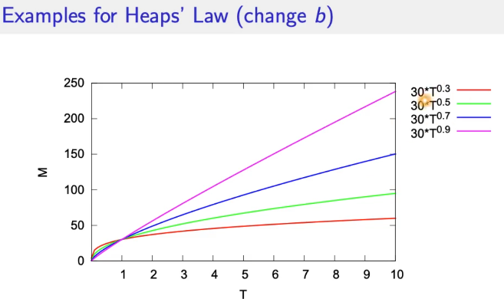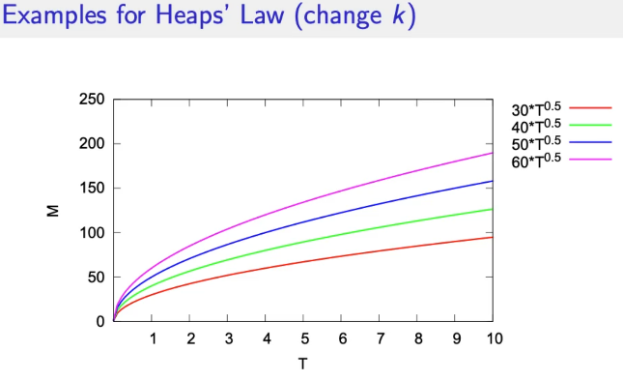

## Exercise

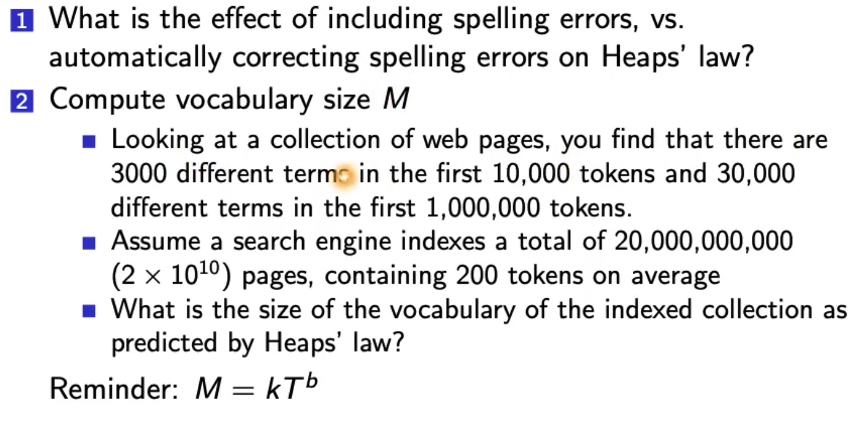

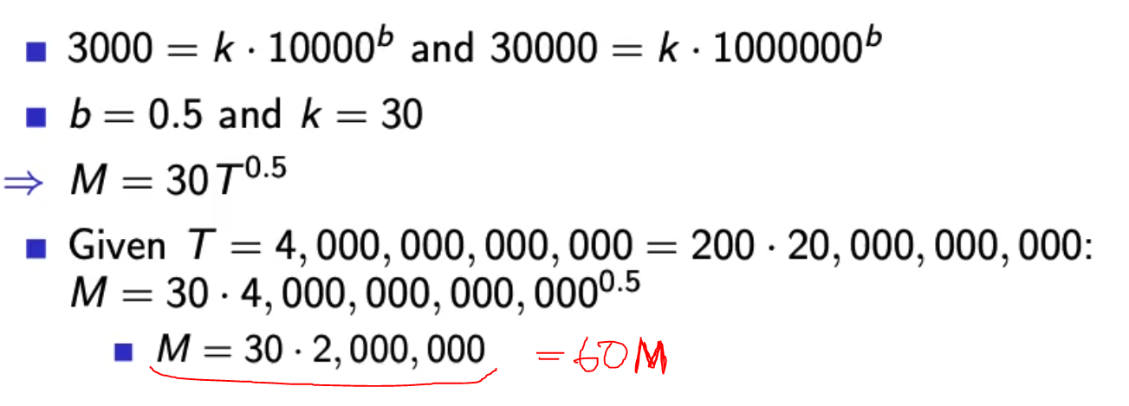

Zipf’s law

* Heaps law: growth of vocabulary
* Zipfs law: frequent vs. infrequent terms
* In natural language, there are a few very frequent termsn and very many very rare terms
* Zipf’s law
  + Ith most frequent term has frequency cfi proportional to 1/i
  + 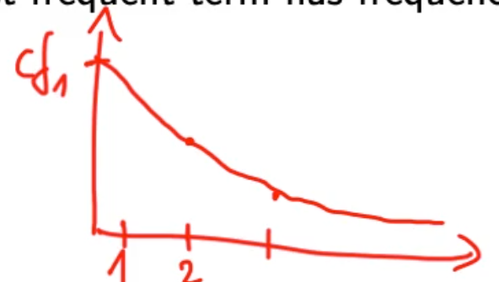
* If the most frequent term (the) occcurs cf1 times, then the second most frequent term (of) has frequency cf2 = cf1/2

## Dictionary compression

* Dictionary is small compared to postings file
* We want to keep it in RAM
* 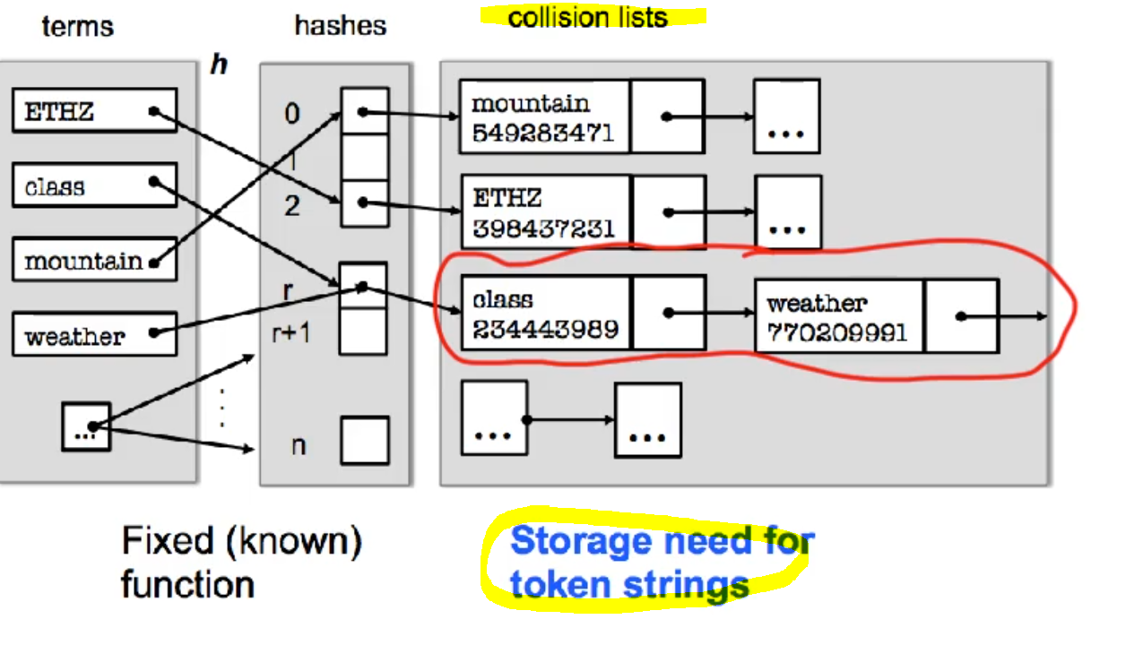
* Dictionary fixed-width entries are bad!
  + Supercalifragilisticexpialidocious
  + Average length of term in english 🡪 8 characters
  + 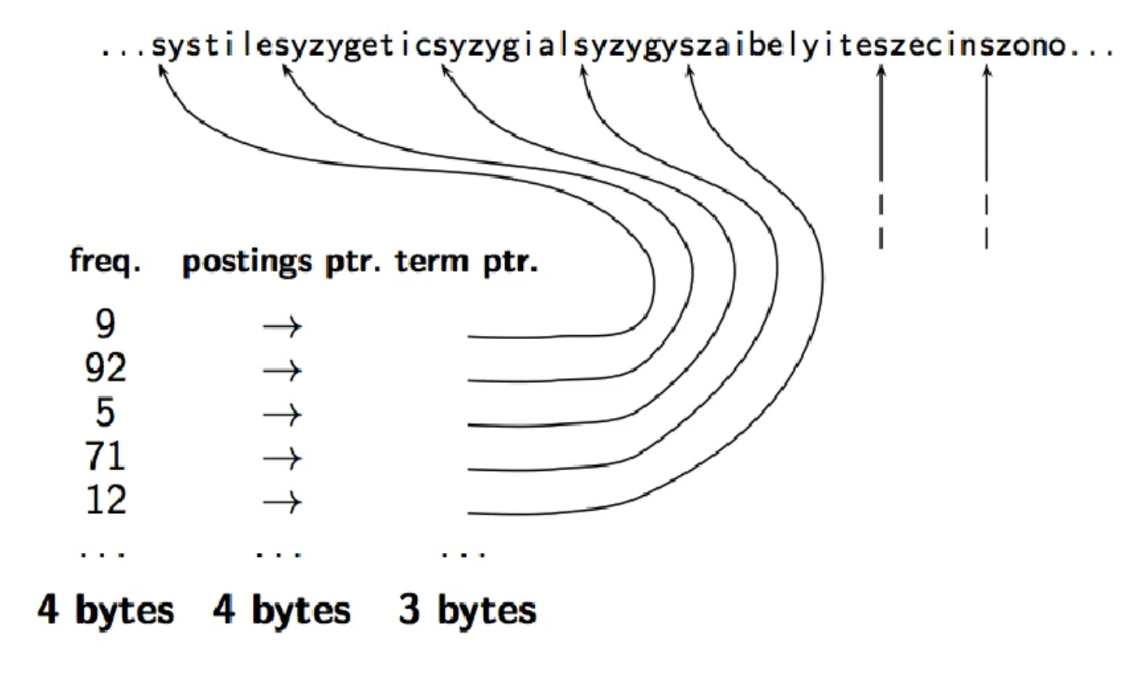
  + Where does the string know how to stop???
  + 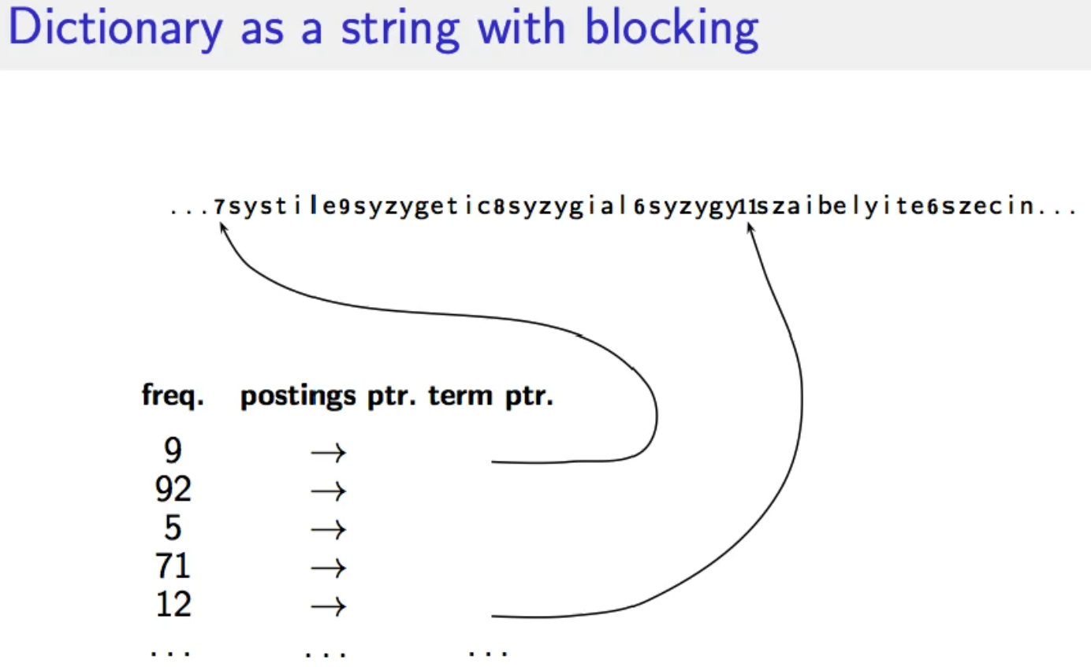
  + 4 terms point to the same block 🡪 Following a pointer into a block, who do I know which term to read?
  + 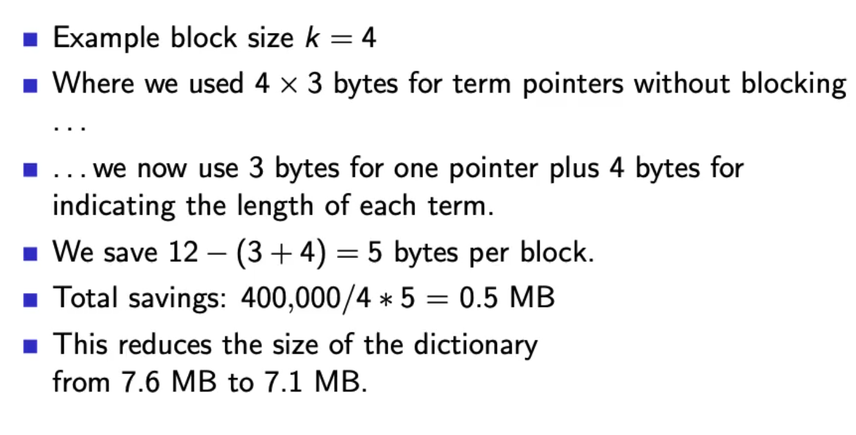
  + 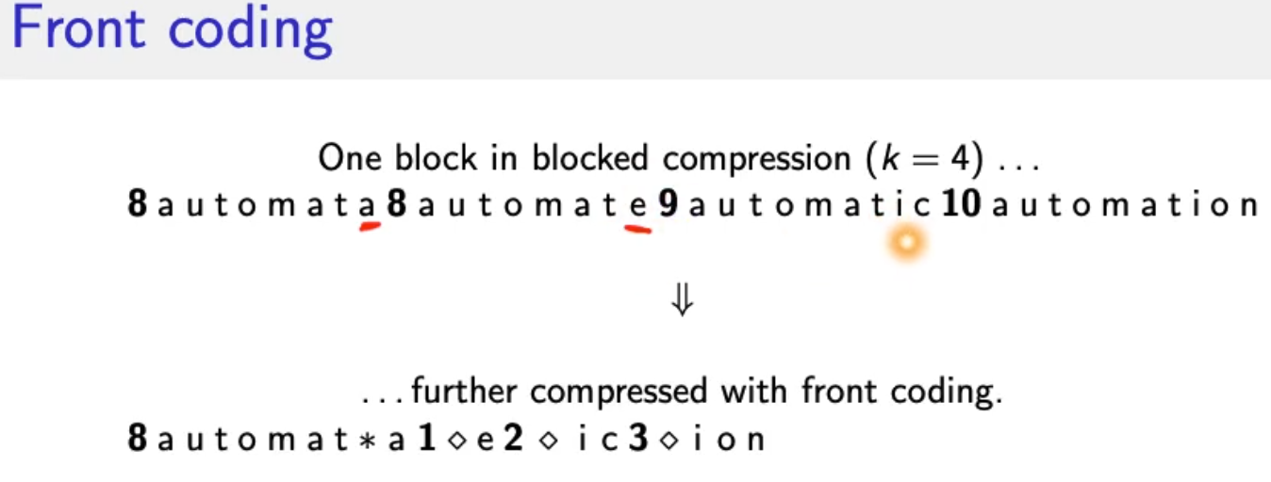
  + 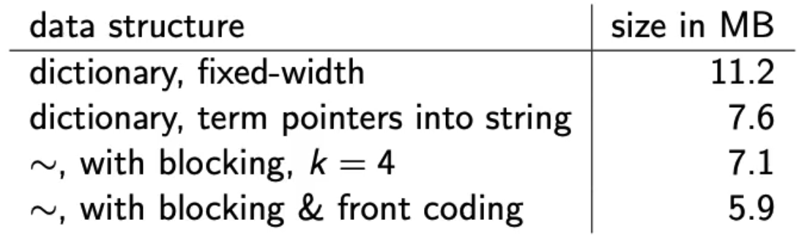

## Postings compression

* Postings file is much larger than dictionary (at least factor 10)
* Key idea: store each posting compactly
* Each postings list is ordered in increasing order of docID
  + Computer : **283153, 283159, 283202**
  + It suffices to store the gaps
    - **Computer: 283154, 5, 43**
* Gaps are small for frequent term, its never worse than storing the docID
* Variable length encoding:
  + For arachnocentric and other rare terms we will use about 20 bits per gap
  + For the and other very frequent terms we will use only a few bits per gap

### Variable Byte (VB) code

Key idea:

* Dedicate 1 bit (high bit) to be a continuation bit c
  + 0000 0000
* If the gap G fits within 7 bits:
  + Binary encide it in the 7 bits and set c = 1
  + 127 = 1111 1111
* If G doesn’t fit in 7 bits:
  + Set c = 0
  + Encode lower-order 7 bits and then use one ore more additional bytes
  + 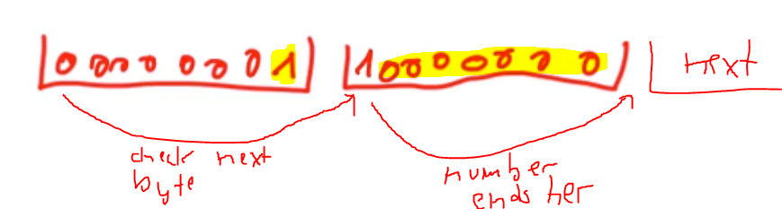
  + 128 = 0000 0001 1000 0000
  + The final byte has the c=1
* 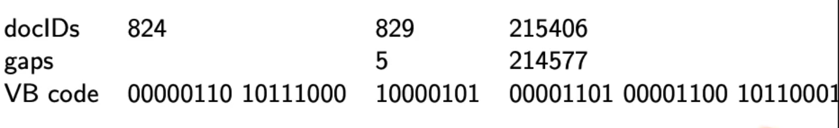

## Gamma codes for gap encoding

* Bitlevel code
* Gamme code is the best known of these bitlevel codes
* Introduce unary code 🡪 one symbol
* Represent 5 🡪 3 = 1110 with final 0
* Represent a gap G as pair of (length, offset)
  + Offset is gap in binary with leading bit chopped off (by convention, always!)
  + 13 🡪 1101 🡪 101 offset
  + Length is the the length of the offset
  + For 13, offset (101) the length is 3
  + Encode length in unary code 🡪 1110
  + Gamma code:
    - Concatentation of length and offset
    - 1110 101 🡪 1110 101
* 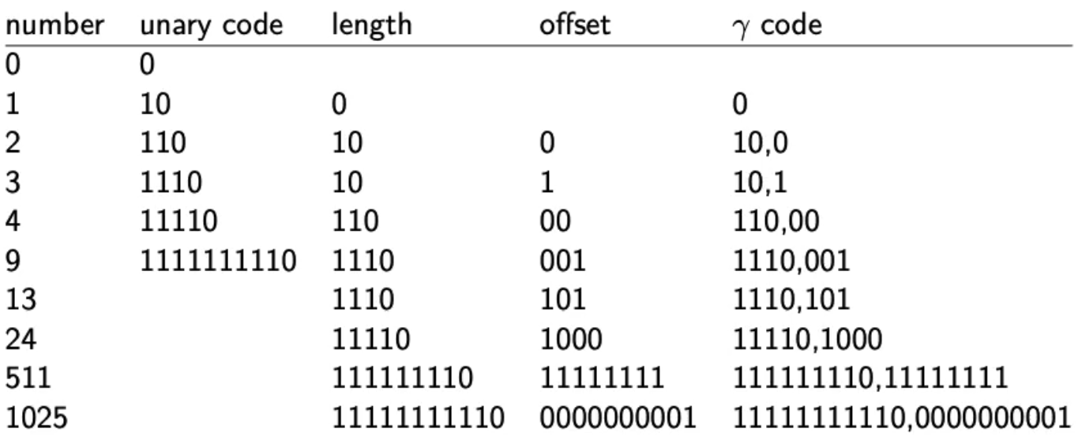
* 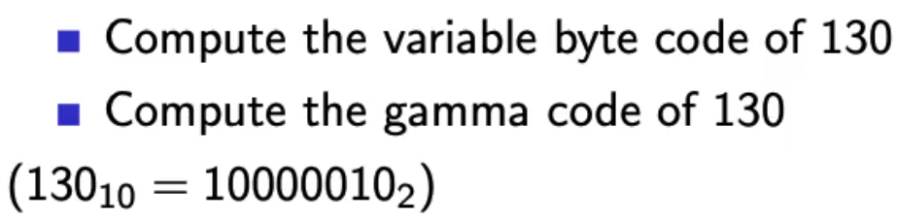
* VB 130 = 0000 0001 1000 0010
* Gamma 130:
  + Offset 000 0010
  + Length: 11111110
  + Gamma Code: 11111110 0000010
* 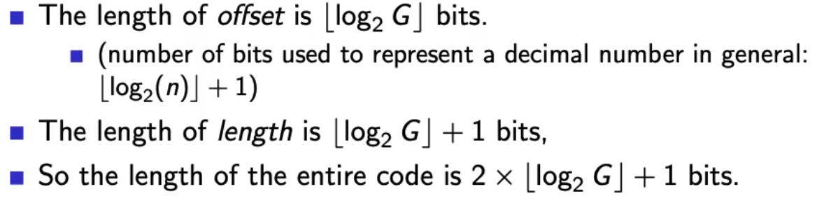
* Gamma codes are always of odd length and within a factor of 2 of the optimal length encoding.
* Gamma code is prefix free! We can do intersection algorithm on bit sequences
* Gamma code is parameter free, universal and doesn’t care about the distributions of gap values
* Machines have word boundaries 8, 16, 32 bit
* Compressing and manipulating at granulartiy of bits can be slow
* Variable byte encoding is aligned and thus potentially more efficient, and conceptually simpler

# Lecture 7 - Scoring

* Ranking: why it is important
  + Boolean
    - match or no match, good for expert users and applications
    - not good for the majority of users
    - gives very few = 0 or too many results (1000s)
  + Ranked retrieval
    - Large result sets are not an issue
    - If most relevant is on top 🡪 😊
    - Just shop top 10 results 🡪 doesn’t overwhelm the user
    - More relevant results are ranked higherr than less relevant results.
* Term frequency: key ingredient for ranking
* Tf-idf ranking
* Vector space model

## Scoring

* Score = query-document pair 🡪 How well does a document fit to a query?
* One-term query
  + Query term does not occur 🡪 score = 0
  + The more frequent the query term in the document the higher the score
  + Query term once = x
  + Query term twice = not 2x, we don’t get double the information
* Jaccard coefficient
  + Measure of overlap of two sets
  + 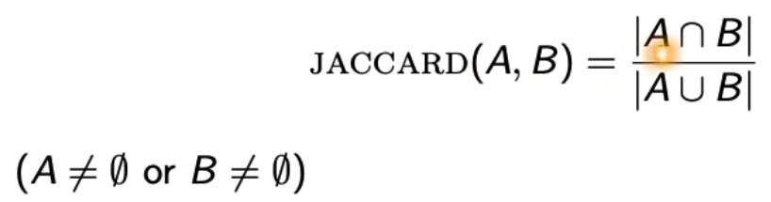
  + Jaccard(A,A) = 1
  + Jaccard(A,B) = 0 if A,B distinct
  + **Depends on size of the document 🡪 large document leads to low scores**
  + **Rare terms are more informative than frequent terms!**
  + **Does not consider term frequencies**
  + (Only exact term match) 🡪 can be fixed by proper normalization

## Term frequency normalization

Before: binary incidence matrix

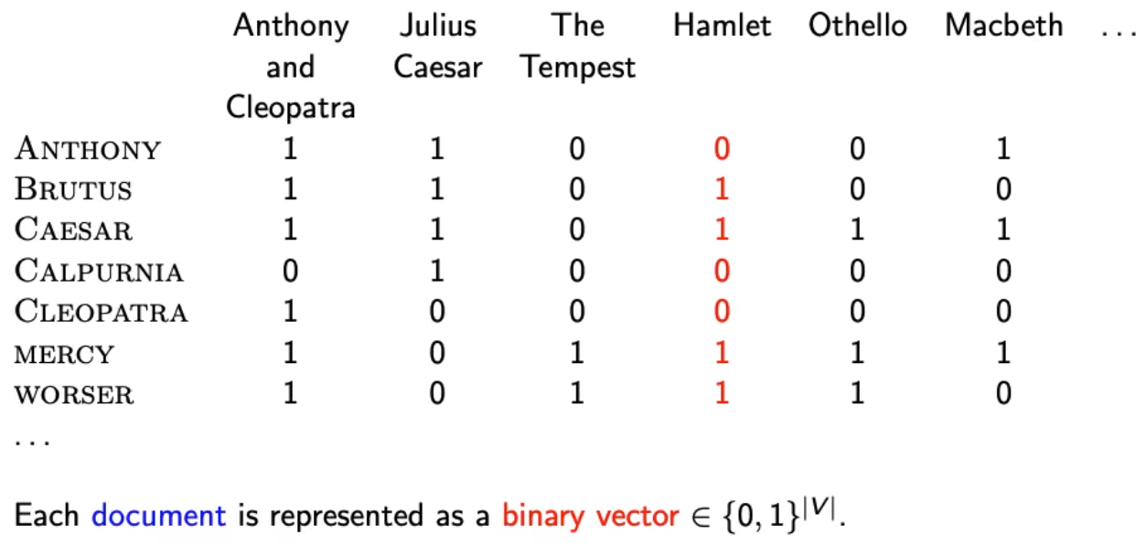

Now: Count matrix

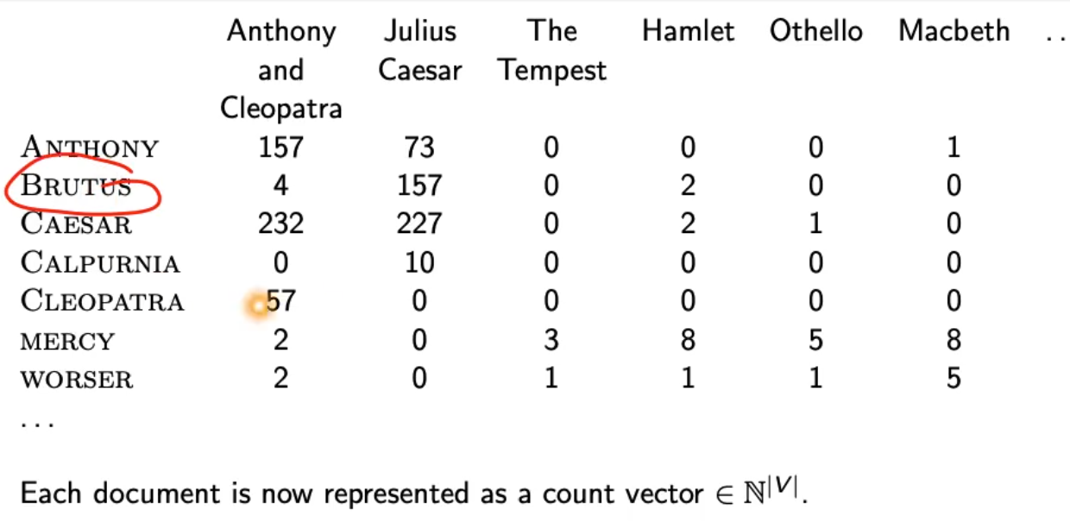

## Bag of words model

* We do not consider the order of words in a document: same representation:
  + John is quicker than Mary
  + Mary is quicker than John
* This is a step back: positional index was able to distinguish these two documents.

### Term frequency tf

* tf(term, document) 🡪 n = number of times the term occurs in this document
* Use tf when computing query-document score
* Raw term frequency is not what we want because
  + tf = 10 not 10 times more relevant than tf=1
* Instead: Log frequency weighting:
  + 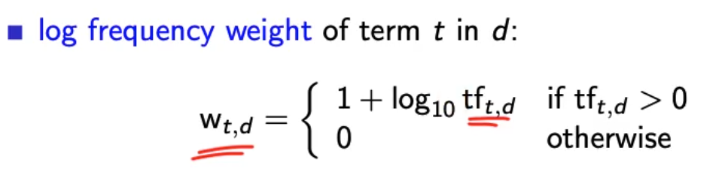
  + 0 🡪 0
  + 1 🡪 1
  + 2 🡪 1.3
  + 10 🡪 2
  + 1000 🡪 4

### Score for query-document pair

* Sum over terms in query and document the log frequency weighted term frequency.
* Score = 0 if none of the query terms is in the document.

## Tf-idf weighting

* Frequency in document vs. frequency in collection
  + Rare terms are more informative than frequent terms 🡪 high weight
  + Frequent terms are less informative than rare terms 🡪 low weight
* We will use the document frequency to factor this into computing the score
* Idf weight
  + Df is the document frequency df(t)
  + Global measure for entire collection
  + Df is inverse measure of informativeness
    - Idf weight
      * Idf(t) = log10 N/df(t)
    - N = number of documents in collection
  + Idf is a measure of informativeness
* 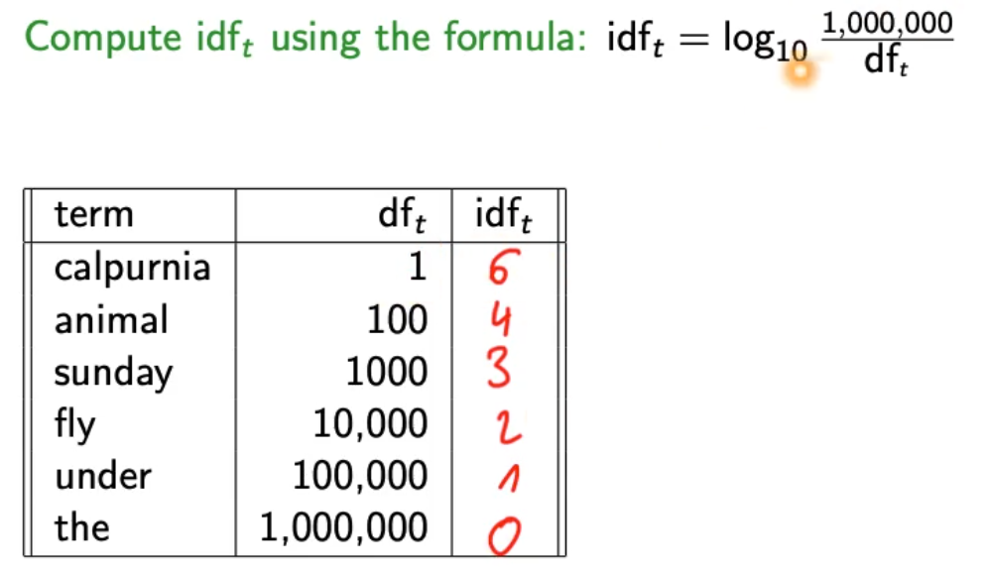
* Logarithm of idf needs to fit the logarithm of tf such that these can “outweigh” each other
* **Idf affects the ranking of documents for queries with at least two terms**
  + Changes absolute numbers but not the ranking
* For example “arachnotcentric line”
  + Idf will increase arachnocentric importance score
  + Idf will decrease line importance score
* 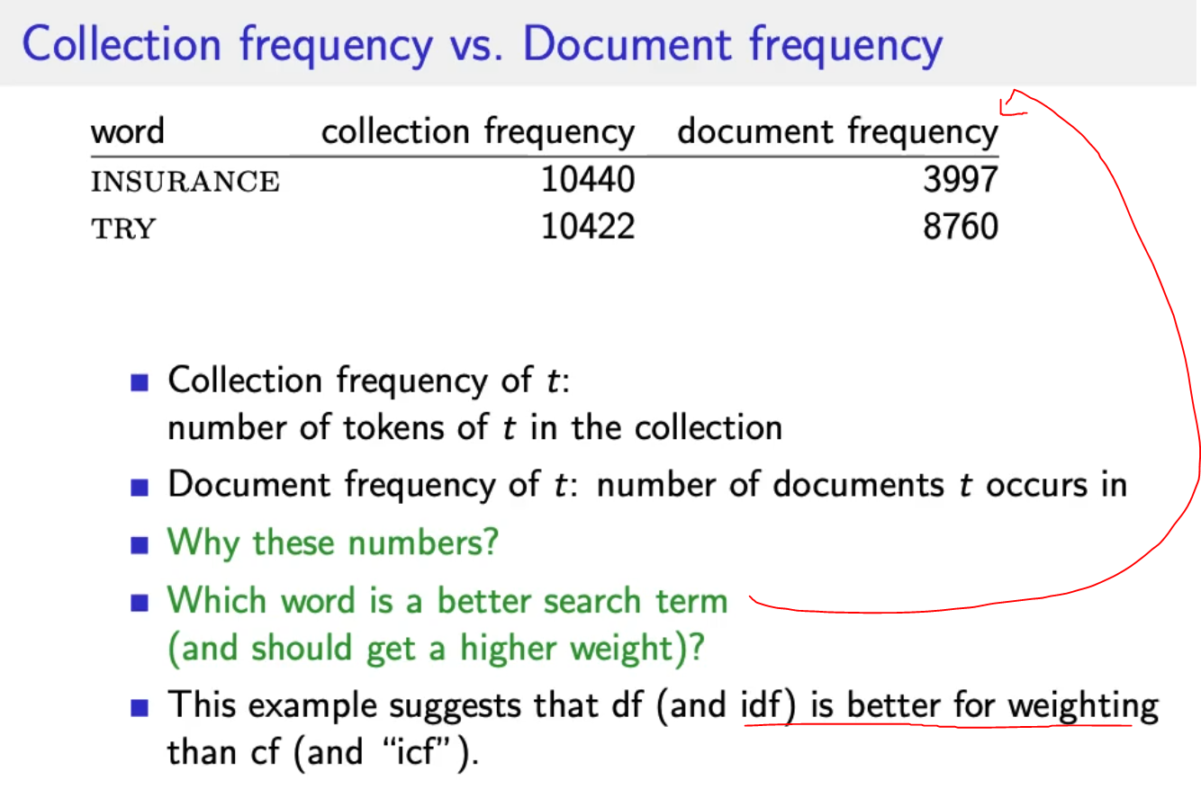
* Tf-idf is the product of tf weight and idf weight
  + 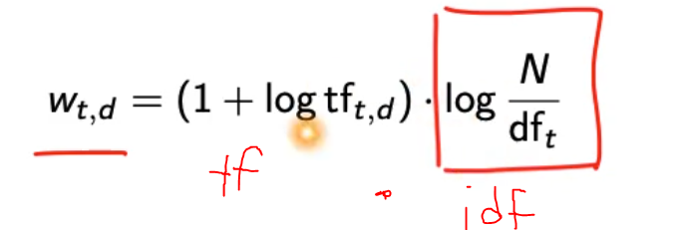
  + Increases if term occurs multiple times in document
  + Increases if term is rare
* 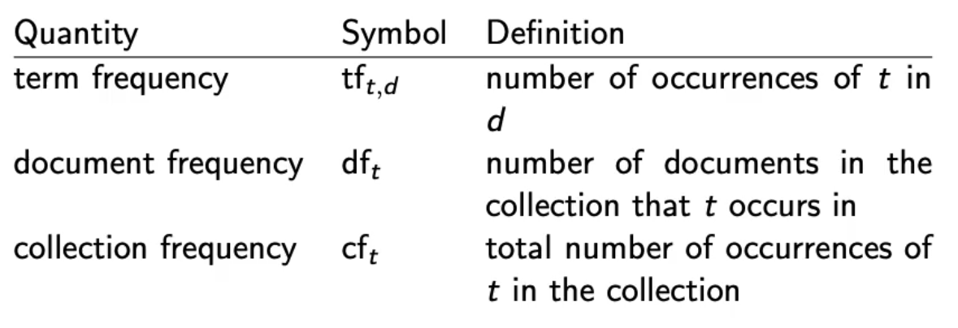

## The vector space model

* tf-idf matrix
  + 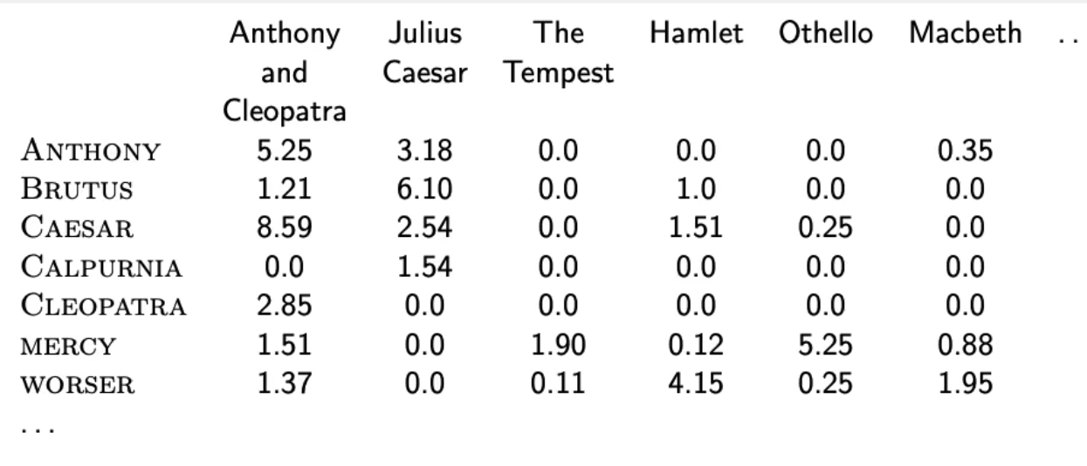
* Documents as vectors e.g. tf-idf vector (high dimensional 🡪 number of words in vocabulary)
* Terms are axes of the space
* Documents are points or vectors in this space
* Very high-dimensional – 10M+ dimensions when apply this to web search engines
* Each vector is VERY sparse – most entries are zero

### Queries as vectors

* Also represent queries as vectors in this high dimensional space
* Rank documents according to proximity to the query
* Proximity = simiarity ~ negative distance
* Rank relevant docs higher than non-relevant (get away from boolean model)

### Euclidian distance?

* + Documents have words often
  + Query is short
  + Bad idea 🡪 large for vectors of different lengths!

### Use angle

* + Rank documents according to angle with query
  + Thought experiment:
    - Document d1, append it to itself 🡪 d1.concat(d1) = d2
    - d1 and d2 semantically have the same content
    - Angle between d1 and d2 is zero = maximal similarity
    - Euclidian distance can be large

### From angles to cosine similarity

* It’s the same to rank documents with cosine(query, document) in increasing order
* 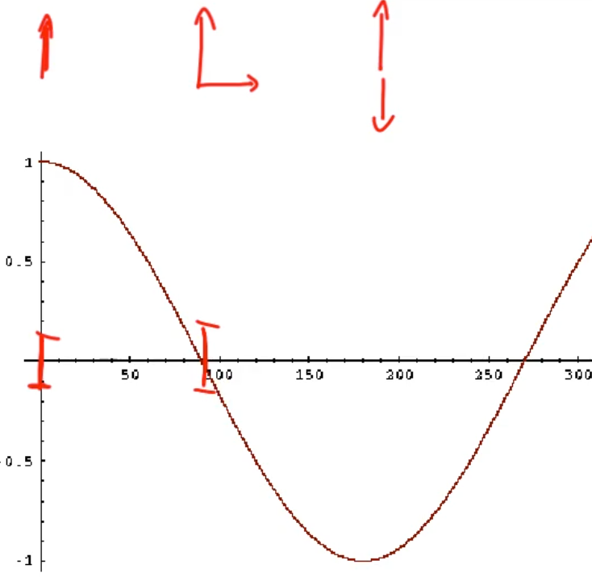
* Value from 0 to 1

#### Length normalization

* Needed to compute the cosine
* L2 norm: 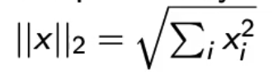
* Maps vectors to multidimensional unit sphere
* 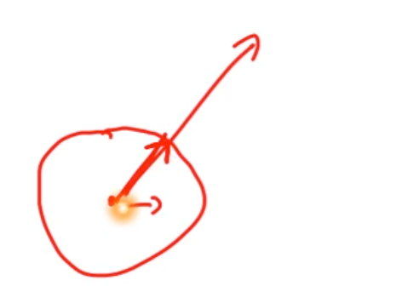
* Longer and documents have weights of the same order of magnitude
* d1 and d2 from example above result in identical vectors

#### Cosine similarity between query and document

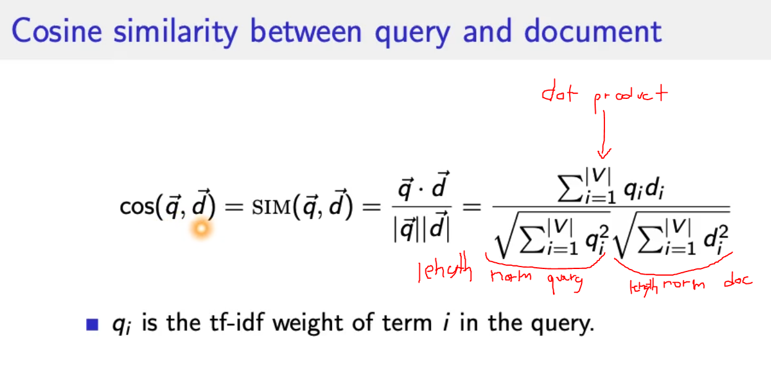

* is cosine similarity between q and d 🡪 cosine(angle between q and d)

## Summary

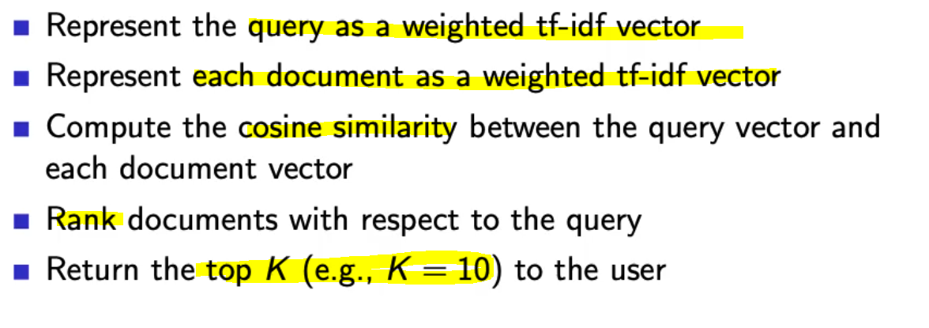

* for first point: just take idf vector from collection, no updates

# Lecture 8 – Ranking, Complete System, Summaries

## How can we measure how important ranking is?

* Interviews: Person just looks at the price, not at the name of the site
* Eyetracking
* Behaviors
  + 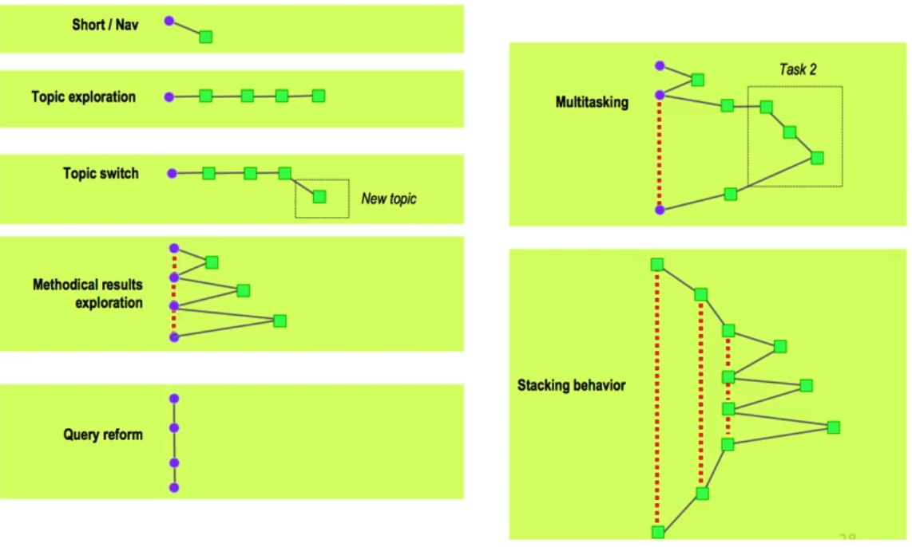
* How many links do people look at?
  + People only look at 1+2 and the 3 a little, rest is irrelevant. 🡪 clicking is even more skewed
  + 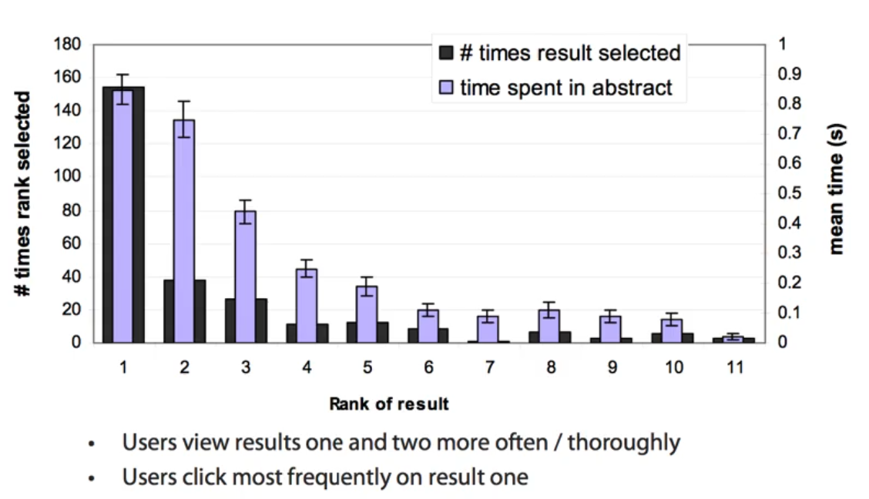
* 🡪 Top ranked page is most important!

## Complete search system

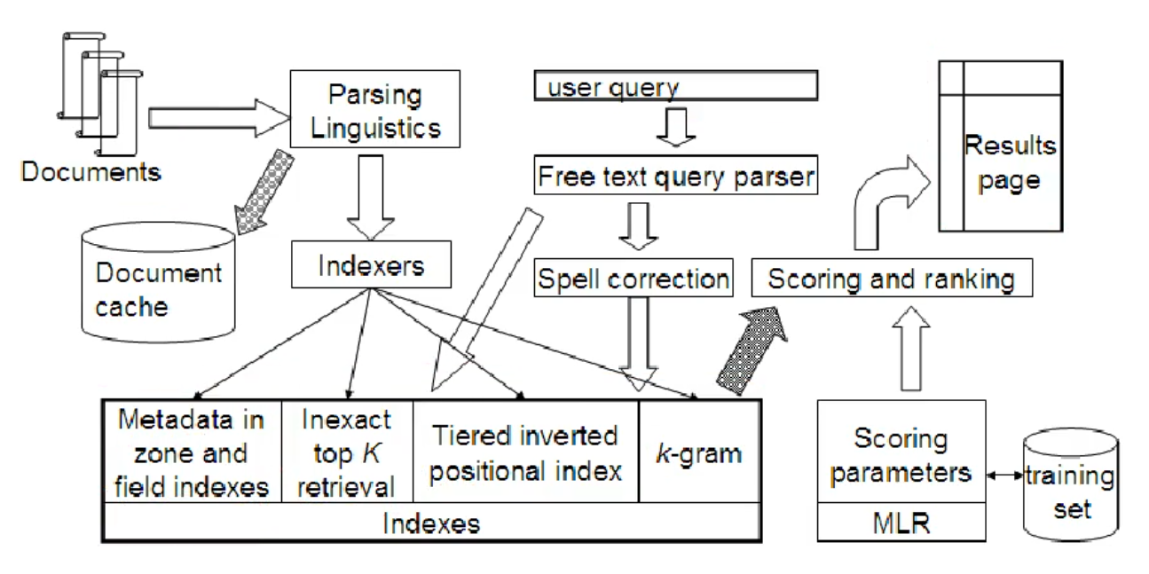

## Tiered indexes

* Create several tiers of indexes corresponding to importance of indexing terms
* During query processing, start with highest-tier index
* Highest-tier index 🡪 titles of documents 🡪 small index
* If we find too few index 🡪 query next index
* Example: 2-Tier system
  + Tier 1: Index of titles
  + Tier 2: Index of the rest of documents

## Document Cache

* We need this for generating snippets (= dynamic summaries)

## Zone indexes

* Separate the indexes for different zones e.g.
  + Body
  + Special paragraphs
  + Italic
  + Anchor text
* Small indexes 🡪 fast queries

## Machine-learning based ranking functions

## Proximity ranking

* Rank documents in which the query terms occur in the same local windows higher than documents where query terms occur far from each other

## Query Parser

* IR systems often guess what the user intended
* London tower 🡪 „london tower“ bigram
* 100 Madison Av, New York 🡪 address 🡪 show map
* Parse query into:
  + Formal specification
  + Phrase operators
  + Proximity operators
  + Indexes

## Implementation of Vector space retrieval 🡪 Ranking

* **Term frequencies in the inverted-index:**
  + 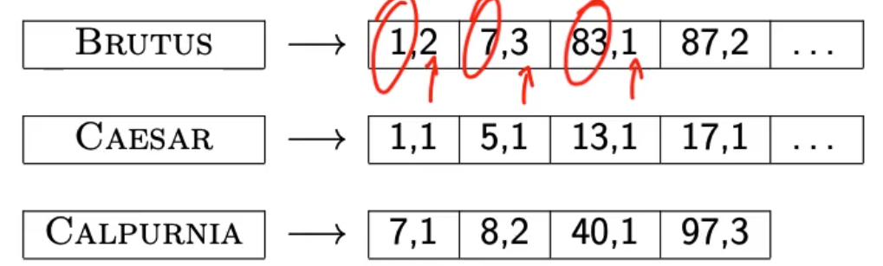
  + Also need positions
  + Store termfrequency(term,document) in addition to docID d in each posting
    - As integer frequency (easier to compress)
  + Additional space requirements are small.
* **How do we compute the top k in ranking?**
  + No need for complete ranking 🡪 best top k (e.g. k = 100)
  + Efficient way of computing top k? 🡪 Heuristic
* **Heuristic**
  + Idea: split into important and unimportant documents
  + Idea 1: **Reorder postings lists**
    - Instead of order by docID
    - Order by **expected relevance** (global)
    - Expected relevance could be 🡪 **PageRank** g(d) of page d 🡪 a measure of how many good pages hyperlink to d
    - Composite scroe: PageRank + cosine similarity to query
  + Idea 2: **Heuristics** to prune the search space
    - Not guaranteed to be correct, but rarely fails in practice
  + Document-at-a-time processing
    - docID/pageRank impose consistent ordering on postings list
    - We can intersect lists normally and compute similarity doc by doc
  + Weight-sorted postings lists
    - Order docs in posting list according to weight 🡪 normalized tf-idf weight
    - Documents in top k are likely to occur early in these ordered lists
      * Supports early termination, probability to change top k decreases with runtime
    - No consistent ordering of documents in postings list anymore
      * We no longer can do document-at-a-time anymore
  + Term-at-a-time processing
    - Completely process postings list of the first query term
    - Create **accumulator** for each docID you encounter
      * Only create while step through lists! (memory requirement)
      * 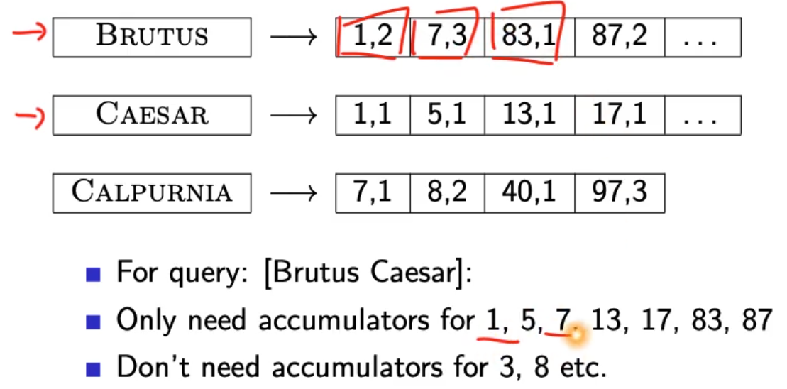
      * Sum up scores from all terms to accumulators for a document
    - Completely process postings lists of the second query term
    - 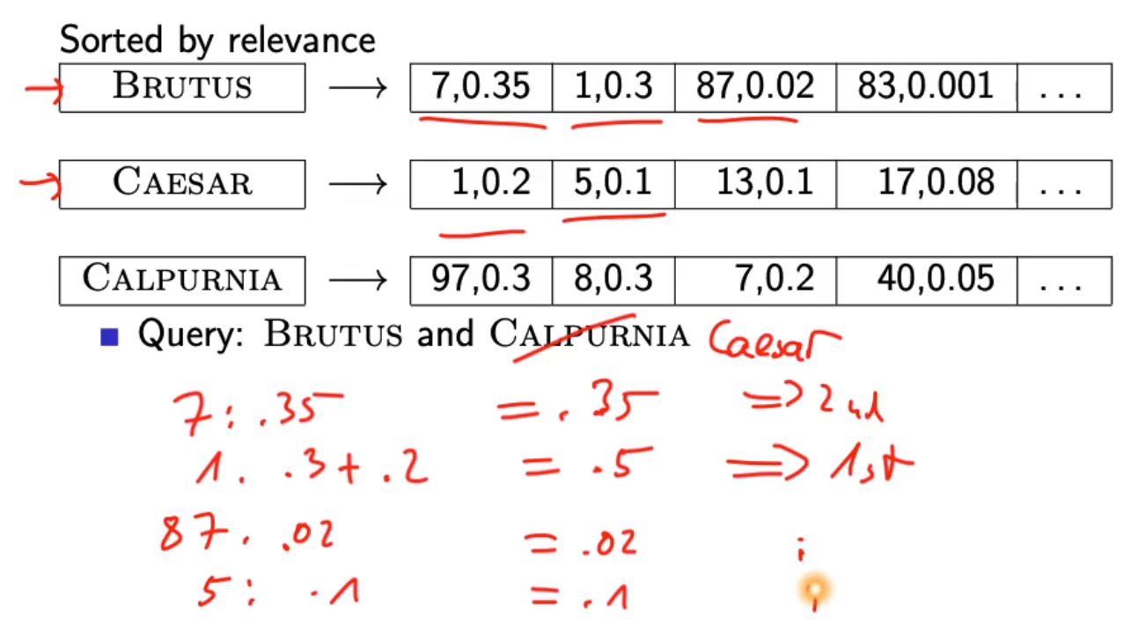

## Summary

* There is no fast optimal algorithm
* Ranking is expensive if similarity is computed for ALL documents 🡪 most docs have similarity score 0 for a query 🡪 potential to speed things up
* In practice: use heuristics to prune search space

## Results presentation

* Most often: list of links with doc description
* User can identify good hits based on description 🡪 no need to view the document
* Show:
  + Doc title
  + url
  + metadata
  + summary
    - static
      * always the same, independent of the query
      * first 50 words of document
      * Extract „key sentences“ (simple NLP heuristic)
      * Complex NLP to synthesize summary
    - Dynamic
      * Present snippets within the document that contain several of the query terms
      * Prefer snippets where query terms occur as a phrase
      * Summary contains all other words also around the query term hits
      * Cache documents 🡪 position in document available from positional index (cached copy can be outdated)

# Lecture 9 – Evaluation

* Measures of an IR system
* Unranked retrieval evaluation

## Measures for a search engine

* How to measure?
  + Quantify speed, size and money
  + Key measure for search engine is user happiness
  + Most important is relevance!
* Which measures are important/relevant?
  + Quality of ranking according to click-on-result-counts
  + Average time to answer a query 🡪 How fast does it search?
  + Robustness regardring multiple request at the same time
  + Summary quality, easy UI
  + Energy efficiency
  + Revenue
  + How fast does it index 🡪 bytes per hour
  + Cost per query in dollars?
* Who is the user?
  + Searcher 🡪 find relevant results
    - Rate of return to search engine (Cookies)
  + Advertiser 🡪 searcher clicks on ad
    - CTR 🡪 click through rate
  + Buyer 🡪 Buyer buys something
    - Time to purchase 🡪 fraction of conversions from searcher to buyer
  + Seller 🡪 Seller sells something
    - Profit per item sold
  + CEO 🡪 Employees are more productive because of effective search
    - Profit of the company
* How to measure relevance:
  + Benchmark document collection
  + Benchmark suite of queries
  + Assessment of the relevance of each query-document pair

## Unranked evaluation

* Query vs. Information need
  + 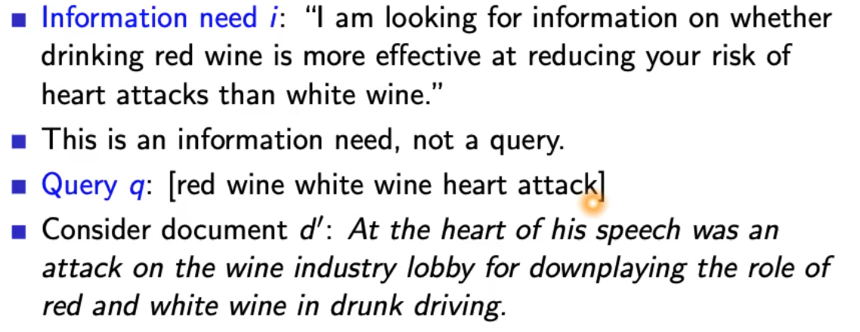

### Precision and recall

* 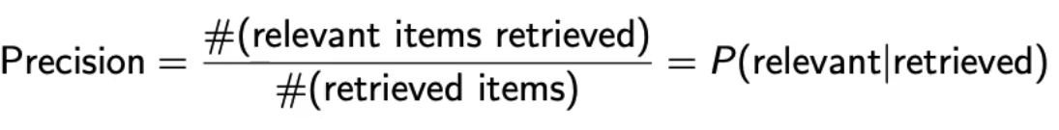
  + You can be very precise but miss a lot of relevant documents!
* 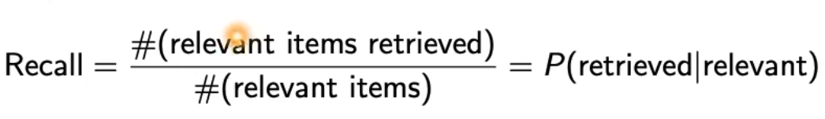
  + Out of everything that is relevant, how much did we retrieve?
* 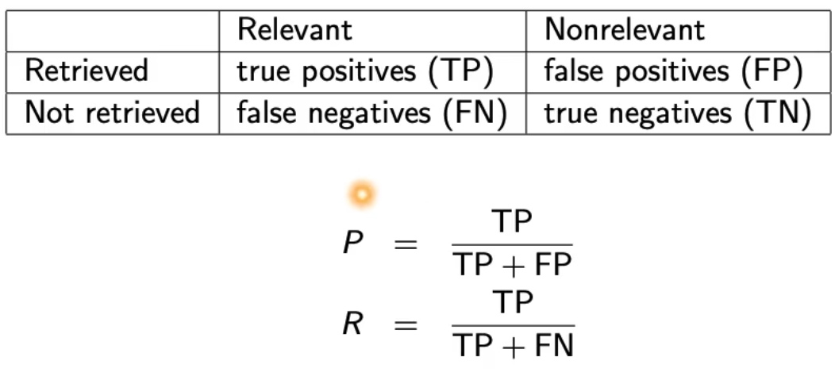
* Precision/recall tradeoff
  + Easy to increase recall 🡪 return all docs
  + Easy to increase precision 🡪 just return 1 document, very sure that it is relevant
  + Find a balance 🡪 combined measure F-score

### Fscore

* 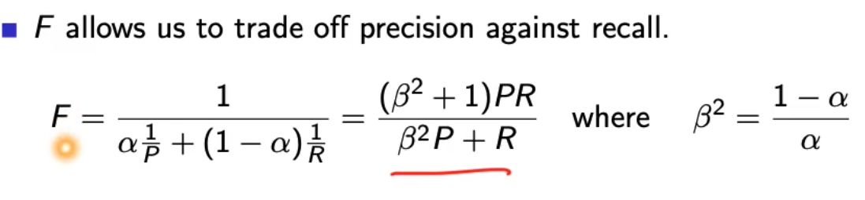
* 
* F1 with beta = 1 or alpha = 0.5
* 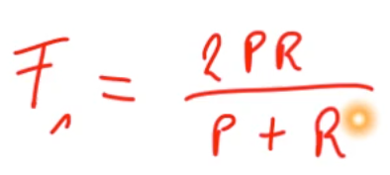
* What value range of beta weights recall higher than precision?
  + More beta more Results 🡪 more recall
* Why the harmonic mean and not the arithmetic mean? 🡪 smooth minimum!
  + Arithmetic mean is 50% for „return-everything“ 🡪 this is too high!
  + Punish really bad performance of either precision or recall!
  + We could just take the minimum(P,R)
    - Not smooth
    - Hard to weight
* Visualization of F1
  + 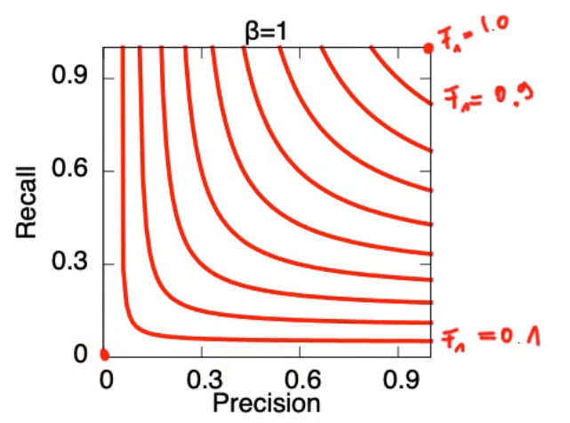
* Visualization if F0.5
  + Precision more important than recall
  + 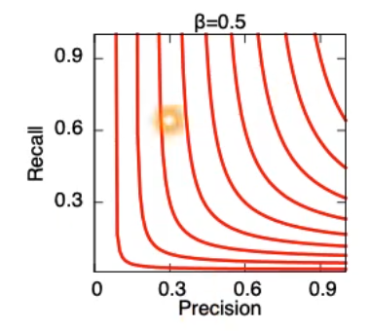
* Visualization if F2
  + Recall more important than precision
  + 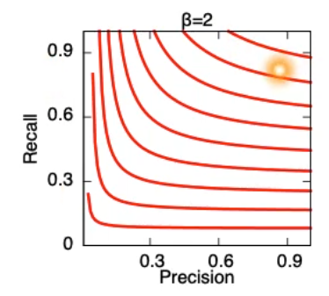

### Accuracy

* 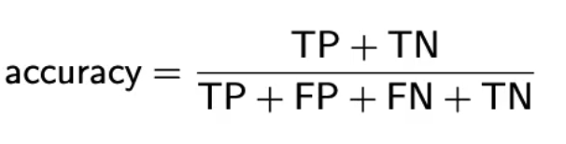
* Fraction of correct decisions
* Useless measure because we can always say no and return nothing because MOST documents are irrelevant

### Examples

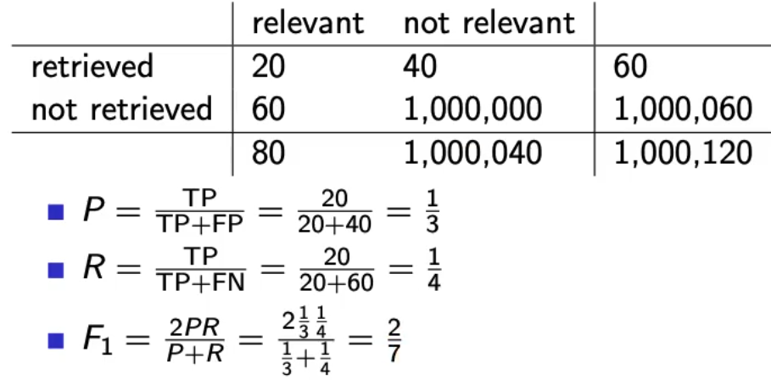

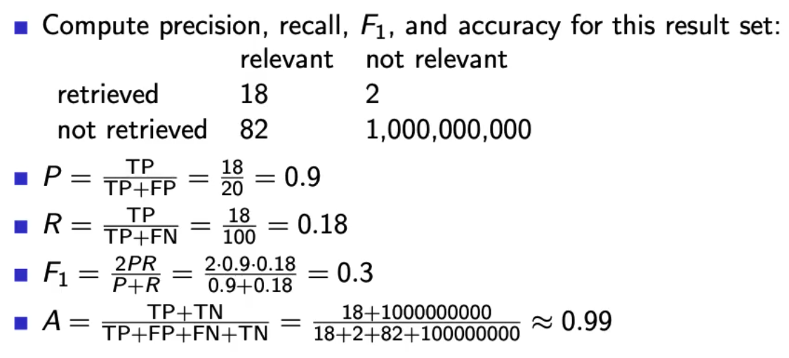

## Ranked evaluation

* Precision/recall/F are measures for **unranked sets**
* Convert these measures to measures of **ranked lists**
* Compute the set measure for each „prefix“
  + Top 1
  + Top 2
  + Top 3
  + Top 4
* Matches of topX sets 🡪 if they match its good!
* Returns list of precision/recall/F values
  + 🡪 results in precision/recall/curve

### PR-Curve

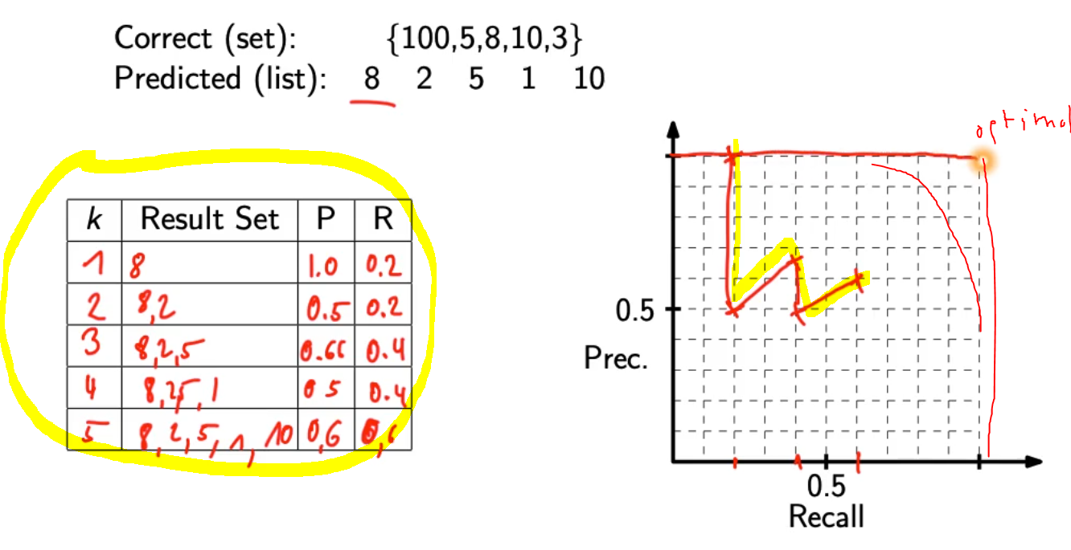

* Interpolate recall 🡪 maximum of all future values
  + Rationale of interpolation: user is willing to look at more stuff if both precision and recall get better

### 11-point interpolated average precision

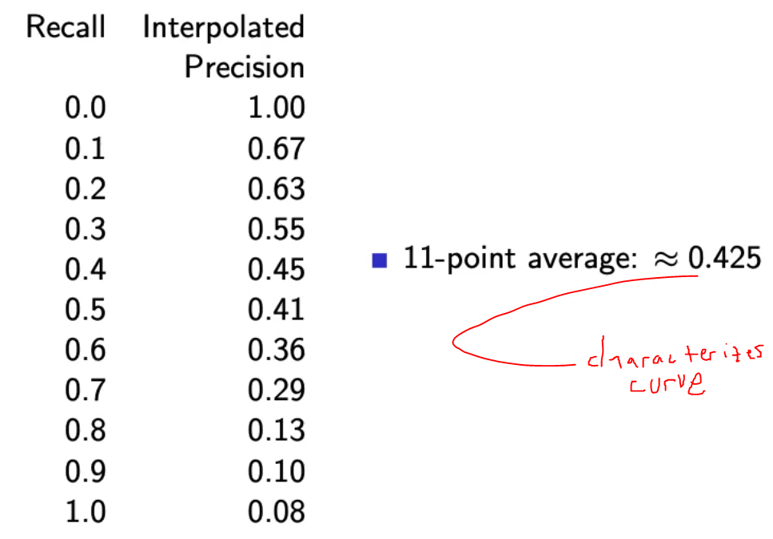

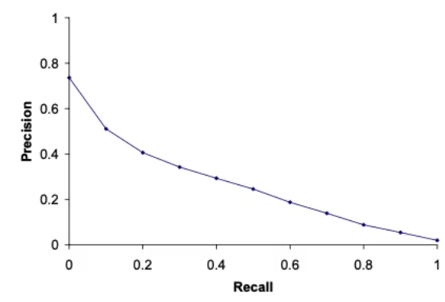

* How can precision at 0.0 be > 0? 🡪 follows from interpolation
* Compute at recall levels, do this for each query in the evaluation benchmark
* Average of queries
* This measures measures performance at all recall levels
* TREC 🡪 typical performance levels

### ROC curve

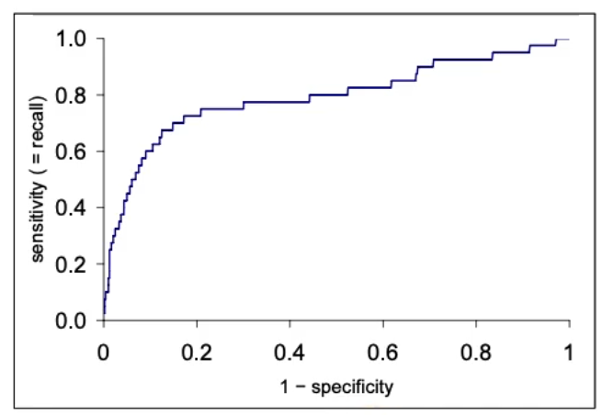

* Similar to precision-recall graph
* Area under ROC curve is a common measure (can be done with PR-curve = same information)